- Introduction:

  - The London Borough of Camden is proposing to re-tender the following Statutory Advocacy Services with a new contract expected to commence on 1st October 2019:

- Independent Mental Capacity Advocacy (IMCA)
  - Deprivation of Liberty Safeguards (DOLS)
  - Relevant Person’s Representative (RPR)
- Independent Mental Health Advocacy (IMHA)
- Advocacy relating to the Care Act:
  - Needs assessment and preparing a care and support plan (section 9 and section 25 of the Care Act)
  - Carers assessment (section 10 of the Care Act)
  - Reviewing a care and support plan (section 27 of the Care Act)
  - Safeguarding (section 68 of the Care Act)

1.2 The London Borough of Camden also commissions non-statutory (generic) advocacy, which enables people who have complex needs and require support, to express their views, have their voice heard and make informed choices. The current generic advocacy provision relates to the following cohorts:
- Older Adults
- Adults with a mental health problem
- Adults with Learning Disabilities

The Council would like to explore its options for continuing to commission non-statutory advocacy services through this engagement, in order to inform our procurement strategy.

- Current Service Model

The existing Advocacy provisions in Camden are split into two contracts, with Provider (A) delivering all the statutory advocacy, as well as generic advocacy for older adults and adults with a mental health problems. Generic advocacy for adults with learning disabilities is provided by Provider (B):
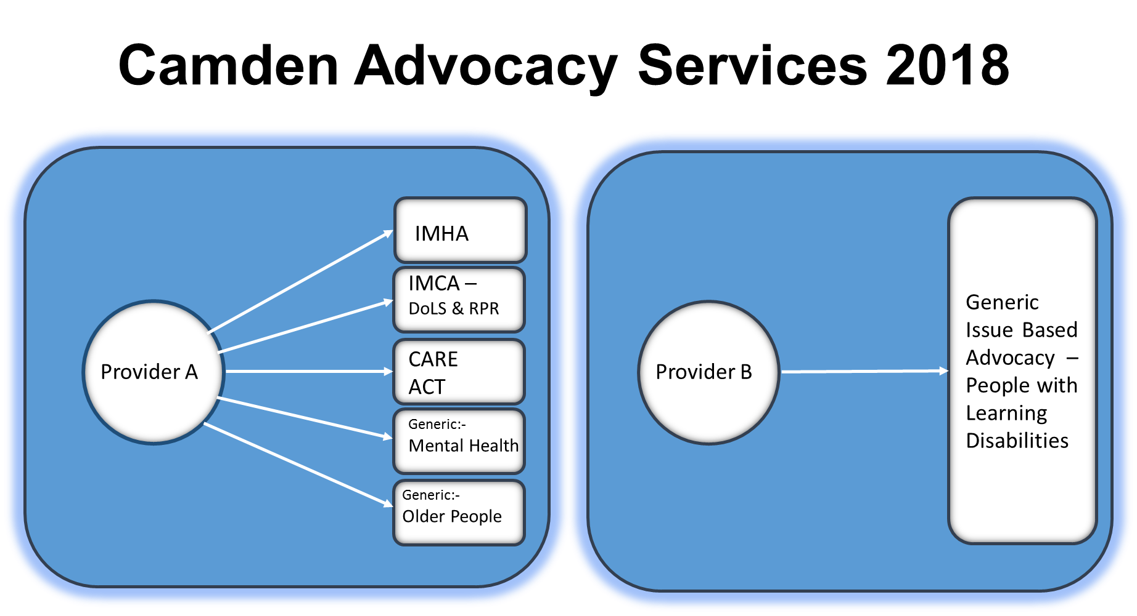

- Proposed procurement for a specialist advocacy pathway

The current model does not allow for a seamless service, which is easy for customers, patients, carers, as well as referring agencies to navigate, in order to access the right service at the right time. The Council would therefore want to explore the option of a single point of entry pathway, which facilitates the individual’s ‘advocacy journey’.

The Council would also welcome partnerships, which would allow for greater choice, especially for specialisms such as advocacy for people with learning disabilities, mental health problems, dementia, sensory impairments, which can be delivered through partnership arrangements from a range of local providers. The pathway may be managed by a single provider, or a lead contractor with one or more sub-contractors.

This pathway will include all three statutory advocacy provisions, with the option to include generic / non-statutory advocacy for all customer groups:

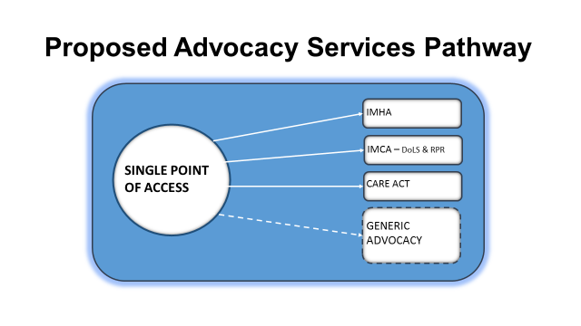
It is anticipated that the contract will be for an initial period of three years with the possibility of two extensions, each of two years in length.

- Pricing Model and Demand

The existing pricing model guarantees an agreed level of funding on the basis of a minimum level of activity, with additional activity funded through tariffs. This decision was made based on the assumption of an increase in demand for advocacy, given the fluctuating demand for advocacy and the unknown impact of the Care Act (customers going through assessment and support planning have a right to access an advocate from 1st April 2015).

The Council would like to review its pricing model and would welcome suggestions, which could potentially be developed as part of the procurement strategy. In addition, the Council would also like to gain an understanding of future levels of demand for advocacy based on local or national trends.

We will be happy to share with you activity data for our existing Camden Advocacy Services at a further engagement event.
- Next Steps

Before commencing a procurement process, we wish to engage with the market to help us shape the process for these services. We would therefore welcome your responses to the questions on the We Are Camden site.

Please complete the online survey on We Are Camden. The Council would appreciate a response by the close of business on 25th September 2018. If this is not possible, it will still be possible to engage with the Council.

We appreciate that this questionnaire might be inaccessible for some so if you or your organisation requires information and support to complete the questionnaire please provide us with your details.

Following this market testing exercise the Council expects to run a procurement exercise with the following key dates:

Milestone | Due date
Market engagement process | Ends December 2018
Procurement strategy Cabinet member decision | January 2019
Advert | Late January 2019
Award decision | Mid-June 019
Implementation | Mid-June - October 2019
Contract start date | October 2019

Interested parties will not be prejudiced by any response or failure to respond to this soft market testing/sounding exercise and a response to this notice does not guarantee any invitation to participate in any future public procurement process that the Council may conduct.

This notice does not constitute a call for competition to procure any services for the Council and the Council is not bound to accept any proposals offered. The Council is not liable for any costs, fees or expenses incurred by any party participating in the soft market testing/sounding exercise. Any procurement of any services by the Council in due course will be carried out strictly in accordance with the provisions of the Public Contracts Regulations 2006 and the Public Contracts (Amendment) Regulations 2009 No. 2992.

Any responses provided will not be treated as commercially confidential and may be used by the Council in the final service specifications used for the contracts but no organisation will be individually identified.
If you are interested in this or any of our advertised contract notices, please register on the Councils e-tendering system, eu supply (https://www.eu-supply.com) -register online.
See the link below for more information:

http://www.camden.gov.uk/ccm/content/business/in-business-in-camden/selling-to-camden-and-strategic-procurement/register-on-esourcing-for-advertised-contracts.en

Tenders will also be advertised on the Compete for website:
https://www.competefor.com

MARKET QUESTIONNAIRE
Camden Advocacy Services

Name:
Organisation:
Designation:
Email Address:
Contact Telephone Number:
Date:
Q1. The proposed procurement for Camden's Specialist Advocacy Pathway for Adults with Complex Needs includes the following three Statutory elements (with the option for generic/non statutory advocacy):
- IMHA
- IMCA (DoLS & RPR)
- Care Act Advocacy
- Generic / non-statutory advocacy for people with complex needs.

What is your general level of interest in bidding to deliver one or more of the services specified within the contract?
Response Q1:

Q2. Are you delivering similar services at present? If so, what services are you delivering and how are these funded/contracted?
Response Q2:

Q3. Operational Model - does your operational model involve the use of premises where you meet clients? Has your organisation adopted an ‘agile working’ approach to deliver services?
Response Q3:

Q4. Please describe your arrangements for supporting service users with disabilities and sensory impairments, as well as non-English speaking service users.
Response Q4:

Q5. What proportion of your current workforce is not paid above the London Living Wage? Would you envisage (or are you) employing staff on zero hour contracts to deliver any elements of the services? If 'yes' please give brief details of the terms of your zero hours contract and whether you offer benefits such as paid sick leave.
Response Q5:

Q6. Do you use volunteers to deliver advocacy services, if so what type of advocacy do they provide? Please also provide details of your volunteer programme.
Response Q6:

Q7. Do you anticipate that you would apply as a partnership working with another organisation(s), including smaller specialist providers, to deliver the services? i.e. for non statutory advocacy
Response Q7:

Q8. The proposed service delivery model includes a single point of entry. We envisage the single point of entry being the lead contactor. What are the opportunities and/or challenges that you see arising from this model?
Response Q8:

Q9. Please describe your referral response times – from point of referral to face to face contact.
Response Q9:

Q10. Would you propose any changes to this model or any different models for delivering the service?
Response Q10:

Q11. Referrals - What are your processes for screening and prioritising referrals? Please describe how you allocate referrals (for all advocacy types) to achieve the right balance of volume, risk/complexity and time. Please provide an example of an optimum caseload.
Response Q11:

Q12. What would you see as the current and future challenges in advocacy services delivery?
Response Q12:

Q13. How do you measure outcomes? Please detail for Statutory and Non-Statutory Advocacy elements.
Response Q13:

Q14. Can you comment on the feasibility of the pricing model which guarantees a certain level of funding on the basis of a minimum level of activity, and funds additional activity through one or more tariffs? What would be the challenges and opportunities that you see with this model?
Response Q14:

Q15. Can you please share with us examples of other pricing models for statutory and non-statutory advocacy? For example, ‘block’ - ‘activity based’ - ‘spot purchase’
Response Q15:

Q16. What are your current rates to deliver the different elements of the service you provide?
Response Q16:

Q17. Do you have any other comments?
Response Q17:

Q19. Would you be willing to meet with us to discuss your views about this proposed procurement further?
Response 19:

Thank you for completing this questionnaire

General Information
Please use the following instructions:
- All clarification questions for Camden Advocacy Services must be emailed to Claudia Gabriel: claudia.gabriel@camden.gov.uk . Please also cc in david.walsh@camden.gov.uk
- Please email the completed questionnaire to David Walsh david.walsh@camden.gov.uk by ___ on ___________

NB: When you email your clarification questions or completed questionnaire please use the following description in the subject field of the email {Insert your company name here - Market Questionnaire Camden Advocacy Services}

