Tybalds regeneration - Landscaping questionnaire
Tybalds Square
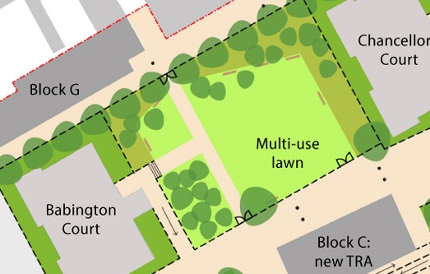
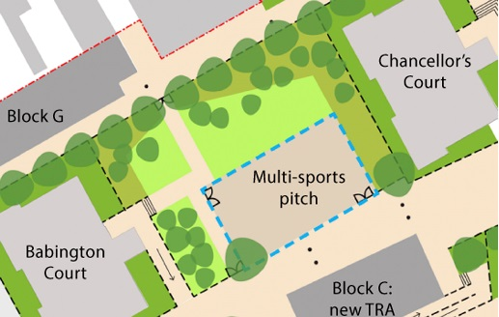
You have told us that Tybalds Square (the area between Babington and Chancellors) needs improvement and better planting, but feedback from residents has not produced clear agreement on what should be in the Square. The landscape designs propose the three options shown here:
Option 3: An unfenced multi-use safety surface providing space for various different games whilst still being open to the rest of the fence-enclosed Tybalds Square with a lawn area and trees.

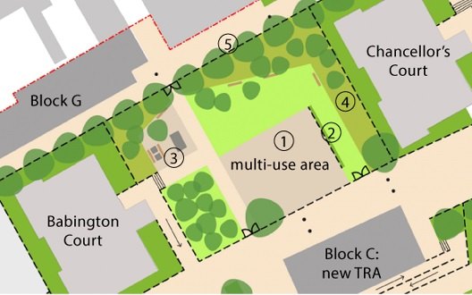
Option 2: A multi-use biodiverse lawn, framed by a wildflower meadow and trees, forming a central communal space in Tybalds Square for residents to use for activities and to relax.

Option 1: A multi-sports pitch enclosed within a 3m-high fence within a fenced Tybalds Square, with a communal landscape around it including a lawn area with trees for residents to relax.

Q1 Which of these three options would you prefer for Tybalds Square?
(Please click on one option box) Option 1 ☐ Option 2 ☐ Option 3 ☐
Q2 Do you have any other comments or ideas for improving Tybalds Square?
Please click here and type your comments

Gates and fencing
Residents have told us they are concerned about safety and anti-social behaviour on the estate.
Traffic calming fences
0.5m pedestal fencing
Vehicle stopping gates
Traffic calming ‘kissing gates’
High balustrade fencing
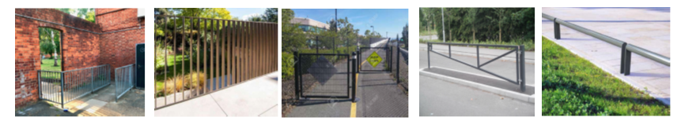

Q3 What are your views about having more gates and fences? (Please tick one box)
☐ No additional gates or fences – The estate should be as open as possible
☐ Fences and gates only around Tybalds Square
☐ Gated with ‘kissing gates’ and traffic calming fences only
☐ Fences and gates around the whole estate

Planting
Q4 What plants would you like to see in Tybalds Square and elsewhere on the estate? (Please click on one or more boxes)
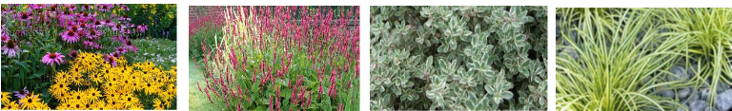
Evergreen plants
Herbs
Tall plants
Bright colours
☐ ☐ ☐ ☐
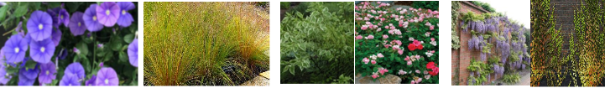
Shrubs
☐ ☐ ☐ ☐
Flowers attracting butterflies
Climbing plants
Grasses

Q5 What other ideas for planting do you have?
Please click here and type your comments

Trees
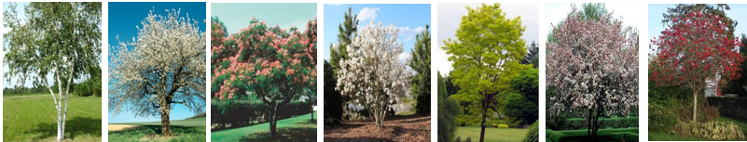
Q6 What new trees would you like to see in Tybalds Square and elsewhere on the estate? (Please tick one or more boxes)
Birch ☐ Cherry ☐ Mimosa ☐ Magnolia ☐ Robinia ☐ Rowan ☐ Crabapple ☐
Q7 What other trees would you like to see on the estate? Where would you like the new trees to be planted?
Please click here and type your comments

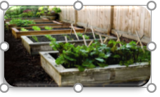
Environment and food growing

Q8 Would you be interested in a food growing area on the estate?
(Please click on one box) Yes ☐ No ☐ Maybe ☐

Q9 Would you be interested in joining a gardening club?
(Please click on one box) Yes ☐ No ☐ Maybe ☐

Artwork

Q10 Would you like to see artwork on the estate?

No artwork ☐ Mural ☐ Sculpture ☐ Mosaic ☐

Other ☐ What other artwork would you like to see?
Please click here and type your comments

Courtyards
Some questions for the residents of Richbell, Springwater, Boswell, Falcon and Devonshire.
Q11 Which block do you live in? (Please specify) Please type name of block here
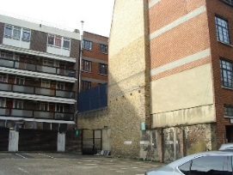
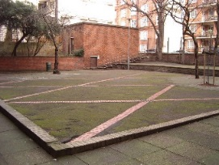
Q12 What would you like in your courtyard? (Please click on one or more boxes)
☐ Flowers ☐ Seating
☐ Play equipment ☐ Table tennis
☐ Planters ☐ Climbing plants

Q13 Is there something else you would like in your courtyard?
Please click here and type your comments

Anything else to tell us?

Q14 Is there anything else you would like to tell us about landscaping on the Tybalds estate?
Please click here and type your comments

Your details
Name Please type your name here
Address Please type your address here
Home phone Type here Mobile Type here
Email Type here

Thank you for giving us your feedback. Please return this form using this freepost address:
Julia Farr, CIP Development, London Borough of Camden, 4th floor, 5 Pancras Square, Freepost RSLT-RJBR-TXAA, London Borough of Camden, Town Hall, London WC1H 9JE (No stamp needed).
Please send any further comments or queries to tybaldsdevelopment@camden.gov.uk

