Local Lettings Plan for Tybalds Estate regeneration programme
Aug 2020 (V17)

1. Introduction

1.1 The development of the revised scheme for Tybalds estate will provide a total of 45 new homes:
- 18 social housing flats for Camden council tenants
- 10 Camden Living flats
- 17 flats for sale

The new homes will comprise a mix of studio, one, two, three and four bedroom homes including five wheelchair adapted homes.

1.2 There will be no demolition of existing homes. It is recognised that building construction will be disruptive for residents living on the estate. A construction management plan will seek to mitigate nuisance during the works.

1.3 No residents will be required to move out of their homes during the construction period.

2. Aims of the Local Lettings Plan

2.1 This Local Lettings Plan sets out the aims and process for all the lettings of new social rented homes to be built by the Council on the Tybalds estate.

2.2 The aims of this Local Lettings Plan (LLP) are to:

- Ensure existing tenants of Tybalds estate are able to share the benefits of building new homes;
- Encourage the continued development of a mixed, stable and sustainable community on the Tybalds estate.

3. Letting arrangements – social rented housing (General Needs)

3.1 Following protocols agreed by Camden Council Cabinet meeting on 5 December 2012 which ratified the Executive’s decision of 1 April 2009, Tybalds council tenants who are in housing need will have priority for lettings of new social rented homes developed at the Tybalds estate, ahead of all other housing applicants.

3.2 The Tybalds Local Lettings Plan will give reasonable priority to council tenants from the Tybalds estate who are in housing need, in accordance with Camden Council’s housing allocations scheme, subject to the following amendments

- 3.2.3 All households currently under occupying their accommodation will be entitled to bid for properties that would provide their bedroom need plus one bedroom. It should be noted that anyone that under-occupies accommodation can be affected by “social sector size criteria” (bedroom tax)

- 3.2.6 Ground floor properties will be prioritised for Tybalds tenants who have a medical recommendation within their bed need for a ground floor home, followed by other Tybalds estate tenants without the ground floor recommendation, based on the time they have lived on the estate.
- 3.2.7 Tybalds tenants with a need for wheelchair accessible accommodation will be given priority to move to one of the five new wheelchair accessible homes on the estate and the vacated homes should be ring fenced for Tybalds tenants. If the wheelchair accessible homes cannot be offered to Tybalds residents they will be offered to Camden residents with a wheelchair need living off the estate.
- 3.2.8 Tybalds tenants and residents who have not been successful in bidding for one of the new homes will be able to bid for one of the flats vacated by tenants who have moved to the new homes.

3.3 Any units that remain unallocated to Tybalds Estate council tenants will be let to applicants in accordance with the housing allocations scheme

3.4 Where vacancies occur on the estate as a result of tenants moving to the new homes, these will be ring-fenced for other Council tenants on the estate needing to move.

3.5 After this process has completed, all future homes becoming available for re-letting will be advertised under Choice Based Letting for all Camden residents who are eligible to bid.

4. Camden Living properties

4.1 The Tybalds Camden Living units sit outside the scope of this local lettings plan.

4.2 Tenants from the Tybalds estate or verified adult children living with them will be given priority by Camden Living for the intermediate rent properties if they meet the criteria for and are registered on Camden Council’s Intermediate Housing Register of Interest where a separate lettings process will apply.

4.3. Any Camden Living homes not allocated to Tybalds residents within an initial period may be offered to applicants without prior connection to the estate.

5 Review and monitoring

5.1 The Council will review this Local Lettings Plan on completion of all the first lettings.

6. Appendix: Boundary of the Tybalds estate
The red lines on this plan shows the boundaries of eligibility for priority in the Local Lettings Plan for Tybalds estate tenants.
NB. The area coloured light blue on the plan is not part of the Tybalds estate and residents in this area are not eligible for Local Lettings Plan priority.

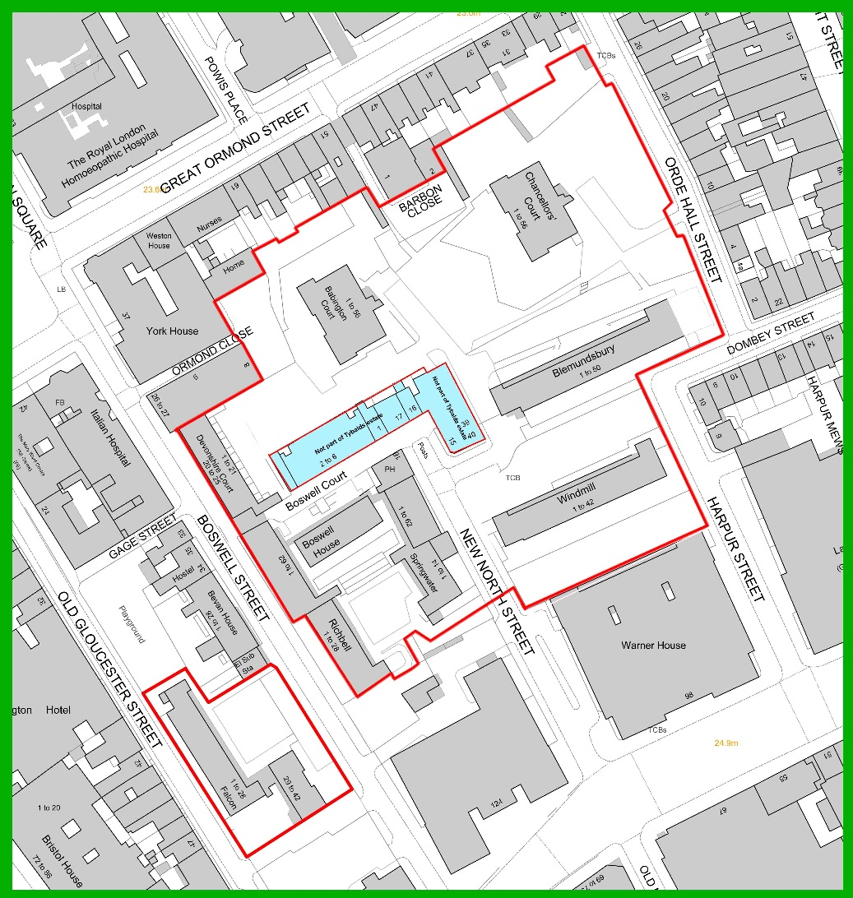

Link to return to top of document

Local lettings plan Tybalds draft V16/ 14-4-20

