
Scheme Ref: TS1407/quietways/ARL/TH


October 2017

Proposed Cycling Improvements on Arlington Road

We are writing to seek you views on our proposal to introduce ‘Quietway’ route in Arlington Road ‘Quietways’ are one of a number of initiatives being developed to improve cycling provision across London.
Quietways are signed cycling routes aimed at encouraging less confident or non-cyclists to take up cycling on streets with low traffic volumes, at the same time providing for existing cyclists who want to travel at a gentler pace and in a safer environment. In order to implement the quietway route on these streets successfully, some minor loading/waiting restrictions would need to be introduced along with additional street signs. Apart from these amendments, no other significant measures will be implemented on the street and this quietway will link other key cycling routes across London resulting in an improved cycling experience for all.
Currently the above street is used for cycling however, the Council believes by introducing proposed measures set out in this leaflet it would encourage a greater number of cyclists to use this street and improve facilities for existing cyclists. Camden’s Transport Strategy’s objective is to promote the use of sustainable forms of transport by implementing infrastructure on the public highway that encourages people to cycle and walk.
The proposed measures have been outlined below and drawings have been included with the leaflet that illustrate the proposals in further detail. There will be some minor parking adjustments to accommodate the new route; however, there will be no overall loss in marked parking bays.

Proposals – Parking Amendments

- Remove 10 metres (2 car parking spaces) of existing residents’ only parking bay opposite 166 Arlington Road and replace with double yellow lines with no loading/waiting at any time restriction in order to accommodate for queuing traffic at the Arlington Road / Parkway signalised junction.

- To compensate for the loss of 10 metres of residents’ parking space as described above, 10 metres of existing paid for parking bay outside 137-141 Arlington Road would be converted into a shared use bay (residents’ and paid for parking).

Overleaf is a visualisation showing how the proposed Quietway signs and road markings could look. These changes will establish consistency amongst all Quietway routes within London, ensuring all users can follow routes with ease.

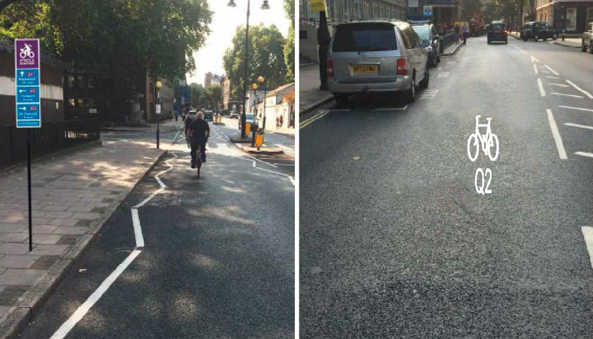

The proposed measures are being funded by Transport for London, if approved these changes

will be implemented in December 2017

This is your opportunity to comment
The Council will be pleased to hear your views on the proposals we are consulting on as well as any alternative suggestions or objections you may have to any aspect of this scheme. Please kindly respond to the consultation by completing the enclosed questionnaire and send to us by 10 November 2017.
RESPONSE SUBMISSION:
You can respond to this consultation via the following methods:
Option 1 Online – submit your response by answering a series of consultation questions and providing your comments on an online form.
Option 2 Email – submit your response via email by sending to tabrez.hussain@camden.gov.uk
Option 3 Post – submit your response using the following free post address (no stamp required) to the London Borough of Camden, Supporting Communities Directorate, Transport Strategy Service, FREEPOST RLZH-UEYC-ACZZ, London, WC1H 8EQ.
Please Note: if you are responding on behalf of an organisation, only ONE reply will be accepted. You must give your full postal address when responding to the consultation if you want us to consider your views.
An equality and diversity form has been included that is voluntary for you to complete and send to us with your response via the email or using free post address as outlined above. Any information you provide on this form will help us in making an informed decision on the scheme.
While it will not be possible to reply to you individually, all comments will be taken into account. The Director of Regeneration Planning will make a decision in November 2017 on whether or not to proceed with the changes and you will be informed via the council’s website of the outcome of this consultation within three months, where possible.
Under the Local Government (Access to Information) Act 1985, your response is available for public inspection; however your personal details will remain confidential. Please only write to us about the consultation issue. If you want to comment on any other matter, please use a separate letter.

Who is being consulted?

The following area is being consulted:

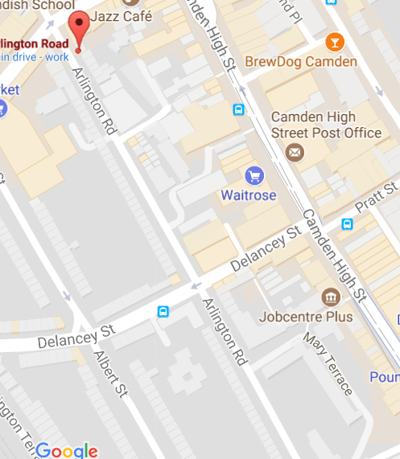 | All properties within the consultation area outlined in black on the plan, Local and Statutory Groups, Emergency Services and Ward Councillors.  If you would like further information then please contact the following officers:

Tabrez Hussain | Simi Shah
Transport Design Engineer | Design Team Manager
Supporting Communities Directorate | Supporting Communities Directorate
London Borough of Camden | London Borough of Camden
Tel: 020 7974 3085 | Tel: 020 7974 2066
tabrez.hussain@camden.gov.uk | simi.shah@camden.gov.uk
Thank you for replying to this consultation

