Proposed BMX cycle track at Harrington Square Gardens: Frequently asked questions

What does BMX stand for and what is it?
BMX stands for Bicycle Motorcross and is a form of cycle sport performed off-road on specially designed tracks.

Who is behind this proposal?
This proposal is led by Camden Council (Environment and Culture Department) in partnership with Access Sport, a national charity leading the development of BMX in London.

Why this location?
Harrington Square Gardens (HSG) emerged as the most suitable site from a detailed option appraisal of a number of potential locations. We will continue to look at the viability of other potential sites, and welcome suggestions.

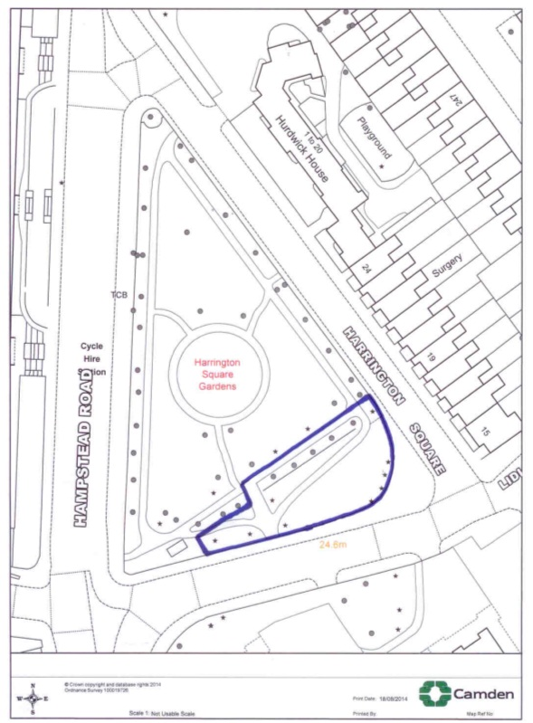
Would the facility take up the whole of the park?
No, the facility will occupy the southern section of the park, as illustrated in the design to the left.

Who will use it & when will it be used?
This BMX cycle track would be a public facility that would be open at the same time as the Gardens. Customers may use the facility unsupervised whenever they wish during these times (the park is open during daylight hours). There would also be supervised sessions and potentially competitions.

The track would be suitable for all abilities and fitness level. Based on other facilities of this kind it is expected that the core user group will be young people between the ages of 9 and 13.

Access Sport would develop ‘Camden BMX’, a volunteer-led community BMX club to be based at the new facility. This club would have BMX bikes, helmets, gloves and pads for hire and offer structured activities at regular times every week.

The club will also actively promote BMX in the local community to raise awareness and draw users. Local schools, community centres and community groups will be the main targets.

Who will pay for it?
The Council will apply to external agencies for funding. It is not currently proposed that any Council funding will be used.

Will the track lead to anti-social behaviour?
There is evidence that BMX tracks do not create anti-social behaviour. There is also evidence they act as a deterrent to antisocial behaviour. A good case study is Rhondda Valley’s BMX track in South Wales, where local incidents of anti-social behaviour are estimated to have halved since the track was built. This case study has attracted wide publicity through national media, and lots of information is available online through ITV and BBC news archives. For a London case study, in Greenwich a BMX facility was built in Hornfair Park, which previously saw significant drug use. A BMX track transformed the use of the park, and despite opposition in advance, has been welcomed by local residents

Young people want BMX provision and experience elsewhere shows they generally behave appropriately and respect their BMX track and its location. A community led BMX Club is a proven method for making young people feel responsible for their actions and act by the rules. The Club will be like a family.

Cantelowes Skate Park (in Cantelowes Gardens) has not led to antisocial behaviour since its installation, despite concerns to the contrary in advance of it being built.

As with all Camden parks and open spaces we will monitor the use of the Gardens as a whole and address inappropriate behaviour. The Garden’s opening and closing time will not change and the facility will not be floodlit.

Is the park safe for this kind of facility?
HSG can be accessed via zebra crossings and entrance in the South West corner, the closest gate to the proposed track. This proposal is being developed hand-in-hand with colleagues in Transport, and this facility will in the near future benefit from a partial network of safe and attractive cycle routes to help users access the facility. As part of the Central London Cycle Grid and by the end of 2016, a number of new cycle routes are scheduled to be completed. The routes will either segregate cyclists from traffic or clearly direct cyclists onto quiet streets with measures to encourage slow driving speeds. The relevant routes due to be completed are as follows (and highlighted on the map below):

- Hampstead Road – Cardington Street – Melton Street – Gordon Street
- Mornington Crescent – Arlington Road
- Regent’s Park - Delancey Street – Pratt Street
- Crowndale Road - Royal College Street – Kentish Town Road
- Royal College Street - Pancras Road – Goods Way – Midland Road – Judd Street
- Goldington Crescent – Ossulston Street – Mabledon Place
In addition, there is also a network of side streets which are quiet where cycling is relatively safe and attractive, for example between Regents Park / Euston Railway cuttings and within Somers Town.

Is it appropriate to promote physical activity for young people so close to a major road?
The section of the park where the facility is proposed is separated from the road by a wide pavement which helps reduce exposure to pollution. As a result, pollution levels at Harrington Square are not significantly higher than other green spaces in the borough with similar facilities (for example Cantelowes Gardens skate park).

What considerations have been made for health & safety?
This track will adhere to guidelines from The Royal Society for the Prevention of Accidents (RoSPA). There will be no hazardous edges, a 3m clearance of overhead branches, no obstacles within 1 metre of the track edge, and provision will be made in the design for beginners. Signage will provide health and safety guidance, for example on supervision and wet weather.

Will the facility be noisy?
There is no evidence to suggest the facility will increase noise levels. The track would be finished using crushed limestone surfacing and sub-base, and unlike skateboards BMX bikes do not make noise against the track surface.

What considerations have been made for existing trees and shrubbery in the park?
The provisional designs will have a negligible impact on the trees in this part of the park. It is envisaged that some pruning and cutting back may be necessary, but nothing more significant.

Will the facility impact paths and access routes of the park?
The provisional designs propose that one of Harrington Square Gardens’ pathways may be adjusted. This path will be reinstated approximately 5m to the north of its current route to ensure residents can still walk continuously around the park and also come within a safe viewing distance of the new BMX facility. A sketch of the proposed changes is shown below.

The blue line marks the existing path and the red line indicates the suggested new route for the path
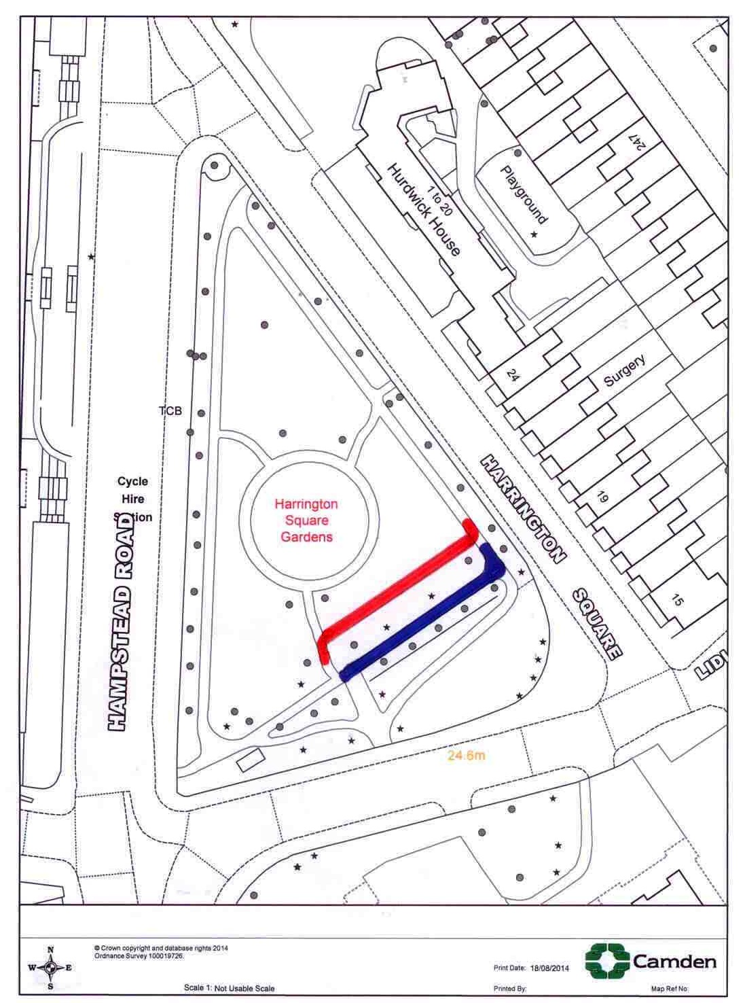

Will there be a visual impact on the park?

The current design proposals attempt to minimise visual impact. Views into the park are shielded on two sides by mature trees, therefore only on the southern edge of the park will the BMX track will be fully visible. From this viewpoint the BMX track will appear as grassy banks / flower beds due to the turfing and planting.

The BMX track would be constructed from basic materials including a hardcore base, layered with topsoil and finished using Dolotrack (crushed limestone) surfacing and sub-base. The banks of the track can be turfed and planted in order to create a pleasant appearance form all directions.

Is the Council planning any other improvements to Harrington Square Gardens?
There are no formal plans for any other park improvements at this stage.

How will this proposal be affected by High Speed 2 (HS2)?

If HS2 goes ahead, current plans suggest that Harrington Square Gardens will be affected by the preliminary works. Exact plans and timescales are changing regularly, but once confirmed a full assessment will be made of the impact on this proposal.

