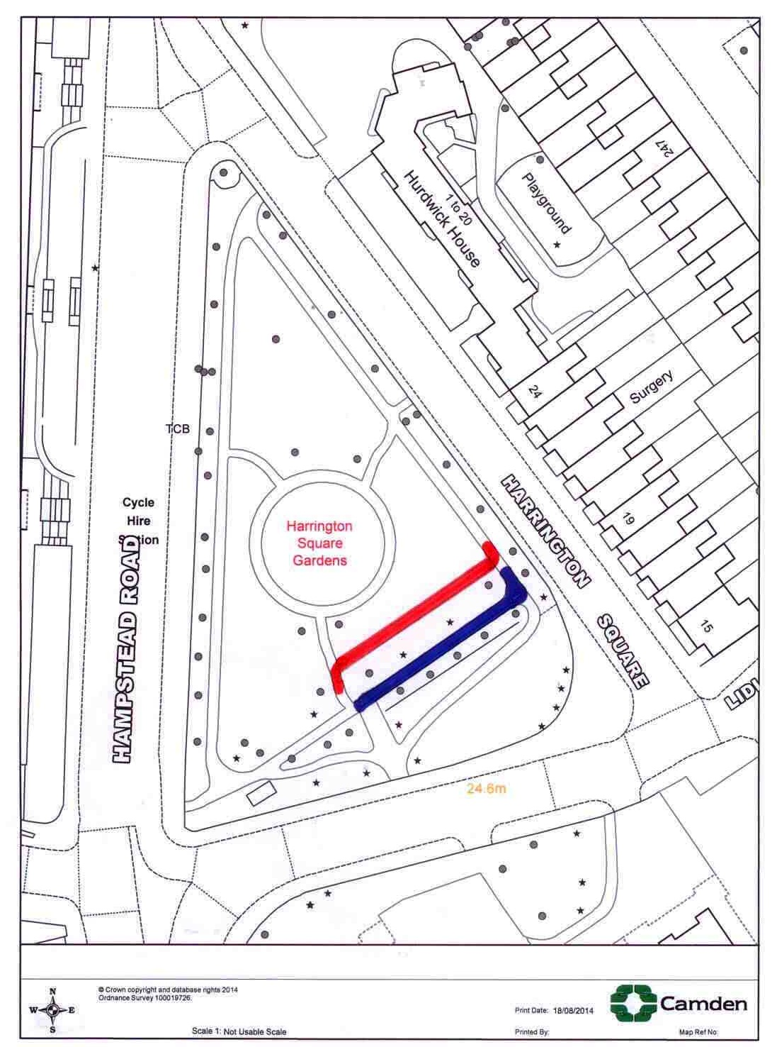
Suggested change to path layout to accommodate preferred track layout

