Notice is hereby given that the Local Authority, The London Borough of Camden are proposing the installation of a Male and Female UriLift auto unit in the vicinity of this location:

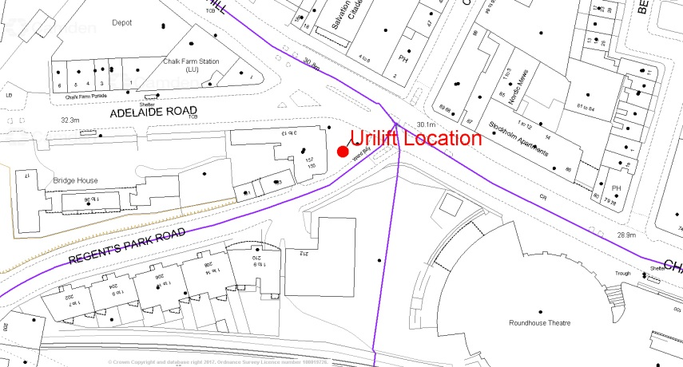

157 Regents Park Rd Camden London NW1 8BB
We would like to install a Uri Lift “pop up” toilet for Male and Female use (www.urilift.com/pop-up-urinals-toilets/urilift-combi/) in the area. This is in order to prevent people from urinating in public areas and near residents homes, as well as to provide better public conveniences for our night time economy.
These urinals would be underground and not visible during the day. They would be raised on a Friday and Saturday night between 10pm and 4am, with the flexibility to change these hours if required.

We are consulting with all residences in close proximity to these sites as well as a number of other interested stakeholders, over a consultation period of two weeks. This period will run until Monday 3rd March 2017. I would like to invite you to share your views on this proposal by email, telephone, letter, or online using We Are Camden (wearecamden.org.uk).

For further information or to comment on the consultation contact:

Michael Hrycak

London Borough of Camden
8th Floor
5PS
5 Pancras Square
London N1C 4AG
Michael.hrycak@camden.gov.uk
020 7974 4499

Notice of a Public Consultation

