Camden and Islington
Safeguarding adults partnership boards

Questionnaire
Keeping people safe from harm

SAPB 2012-13

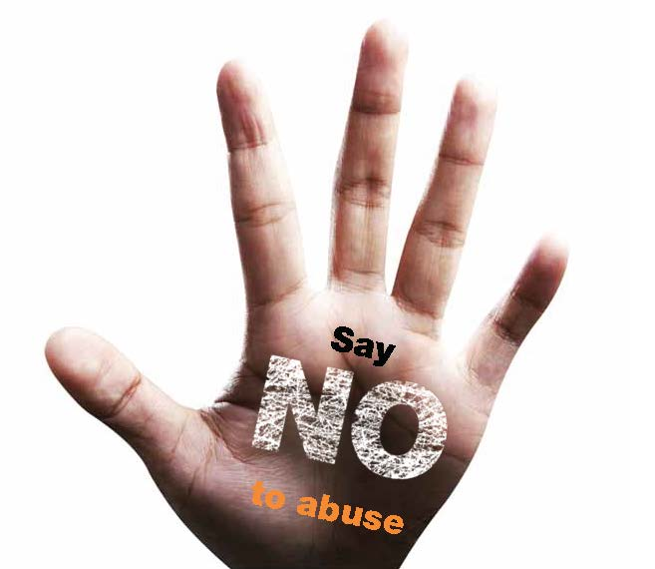
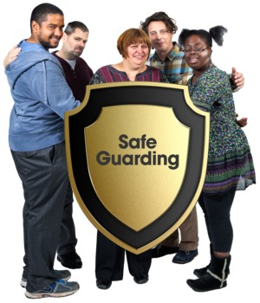
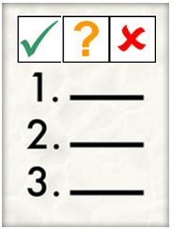

What do you think we should do
over the next few years
to help people stay safe?

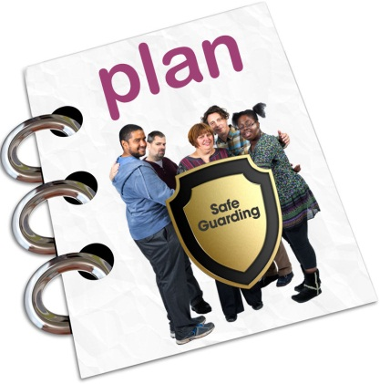

We are asking people in Camden and Islington about our plan for helping people stay safe

The plan will be for the years 2015 to 2018

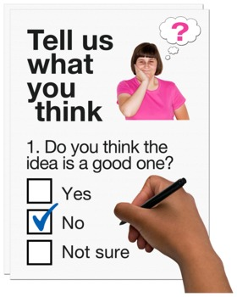

Please tell us what you think about our ideas for the plan by filling in this questionnaire

Empowerment

People listen to me when I tell them what I want
to happen as a result of the safeguarding investigation

We think it is important to

- ask adults at risk how they want to be kept safe

- tell people about new scams and fraud

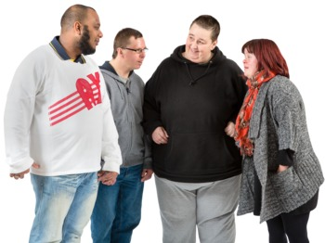

- help people to share stories and experiences

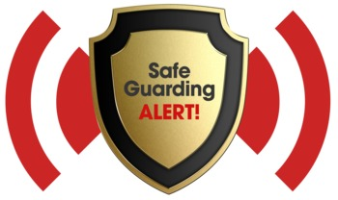

- listen to what it is like to be safeguarded

Empowerment

People listen to me when I tell them what I want
to happen as a result of the safeguarding investigation

Do you think it is important to put this in our plan? Please only tick 1 box

yes

no

I’m not sure

Please tell us why you think this
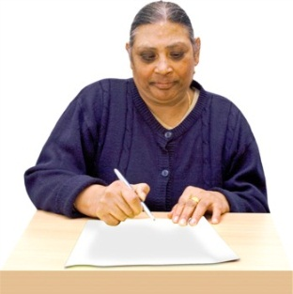

What do you think we could do to give people who are at risk of harm a say in how they are protected?
A
B
C

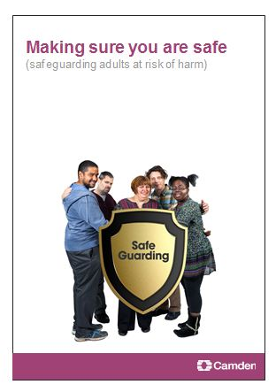
Prevention

I can have easy read information about

- what abuse is
- how to know when abuse is happening
- what I can do to get help

We think it is important to

- have information about how to protect yourself

- deal with bad care before it turns into abuse

- stop people with extreme views from targeting vulnerable people

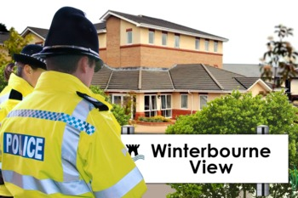

- learn from serious incidents around the country

Prevention

I can have easy read information about
- what abuse is
- how to know when abuse is happening
- what I can do to get help

Do you think it is important to put this in our plan? Please only tick 1 box

yes

no

I’m not sure

Please tell us why you think this

How would you like to have your information about abuse? For example, in a leaflet, on the Internet or with a training event…
1
2
3

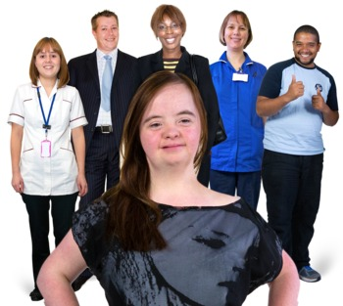
Proportionality

I know that staff and other professionals will do what I agree is best for me

They will only get involved as much as they need to

We think it is important to

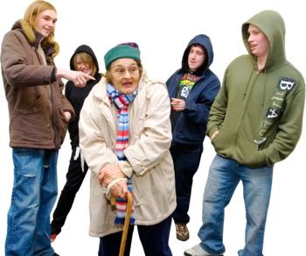

- know about and deal with the risks people face

- deal with serious cases of abuse in the right way

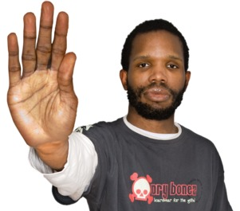

- only take away people’s freedoms if we think this is the only way to keep them safe or give them the right care

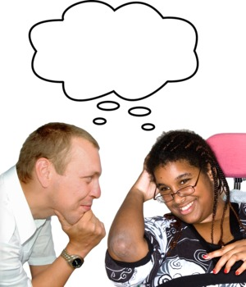

- help adults at risk and families to find solutions

Proportionality

I know that staff and other professionals will do what I agree is best for me.
They will only get involved as much as they need to.

Do you think it is important to put this in our plan? Please only tick 1 box

yes

no

I’m not sure

Please tell us why you think this

What do you think we could do to help people feel sure that staff and professionals are doing their best for them?
here 4 U

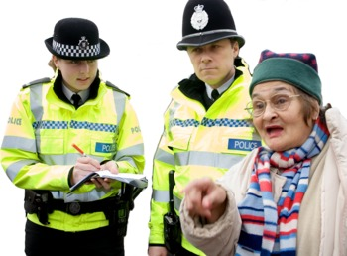
Protection

I get help and support to report abuse
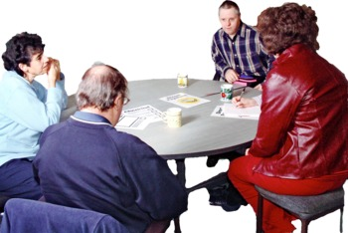

I get help to take part in the safeguarding process as much as I want and am able to

We think it is important to

- look into reports of abuse as quickly as possible

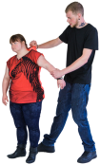

- train staff and volunteers to keep people safe

- help people get their voices heard

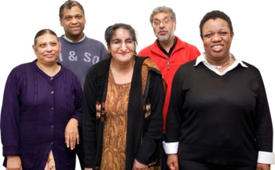

- support minority ethnic groups to report abuse

Protection

I get help and support to report abuse

I get help to take part in the safeguarding process as much as I want and am able to

Do you think it is important to put this in our plan? Please only tick 1 box

yes

no

I’m not sure

Please tell us why you think this

What do you think would help people at risk of harm, and their families and carers, to take part in the safeguarding process?

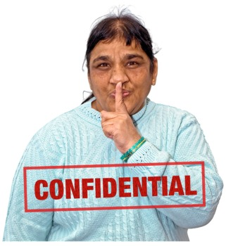
Partnership

I know that staff and other professionals keep my personal information private

They only share what is necessary

They work together to get the best result for me

We think it is important to

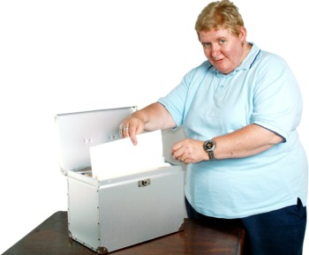

- develop clear information sharing arrangements

- work more with voluntary organisations

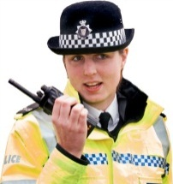
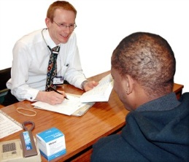

- help GPs, police, and housing to report abuse

- check we have the right people on the board

Partnership

I know that staff and other professionals keep my personal information private.
They only share what is necessary.
They work together to get the best result for me.

Do you think it is important to put this in our plan? Please only tick 1 box

yes

no

I’m not sure

Please tell us why you think this

How would you want Camden and Islington to work together to keep people safe from abuse and bad care?

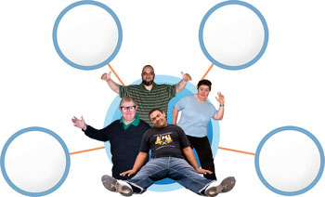
Accountability

I understand the role of everyone involved in my life as someone who uses services

We think it is important to

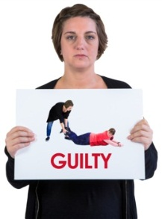
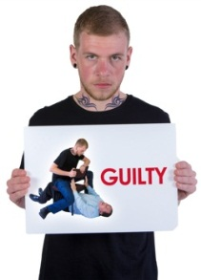

- help more victims of abuse to get justice

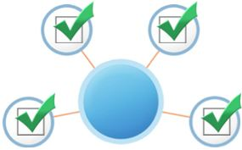

- check care and health services are good enough

- deal with abusive care and health services

- keep making safeguarding better

Accountability

I understand the role of everyone involved in my life as someone who uses services

Do you think it is important to put this in our plan? Please only tick 1 box

yes

no

I’m not sure

Please tell us why you think this

What can we do to make sure victims of abuse in Camden and Islington get justice?

A few more questions

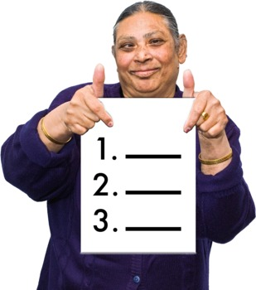
Can you think of anything else that would make a big difference and help people stay safe?

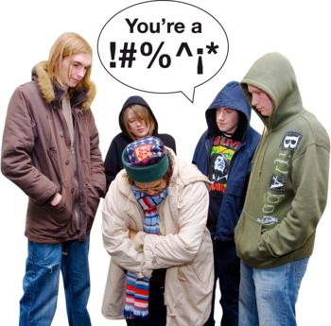
What types of abuse and bad care do you think people in Camden or Islington are most at risk from?

Who would you tell if you were worried that someone was being abused or not looked after properly?

How can we make it easier for people to report abuse or bad care?

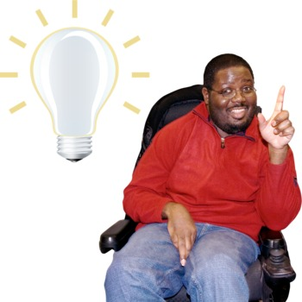
Please use this space to tell us anything else you want to say about our plan for keeping people safe

To find out more about safeguarding, download the easy read guide here

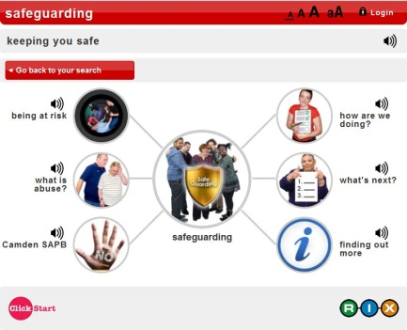

Or check out the safeguarding wiki website here

About you

You do not have to answer these questions but your answers will help us give a better service to different groups of people

How old are you? (please tick 1 box only)

I am a man

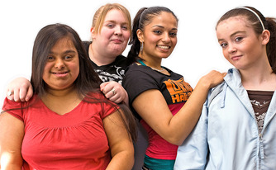

I am a woman

What is your ethnic group? (please tick 1 box only)

White

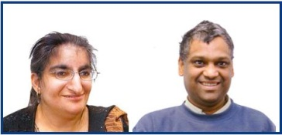

Asian

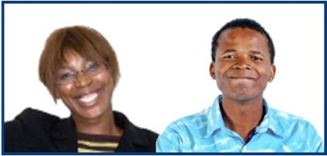

Black

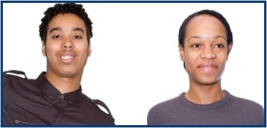

Mixed

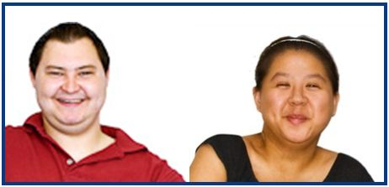

Other
Do you have a disability?
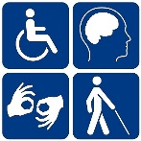

yes no

Please tick the box (or boxes) that apply to you
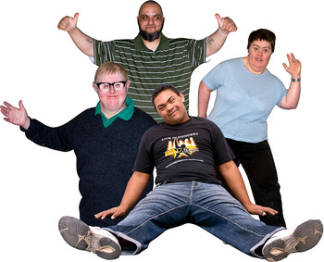

learning disability

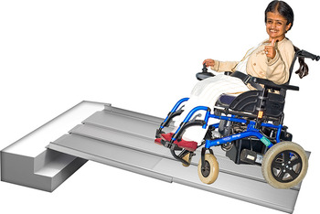

physical disabilty

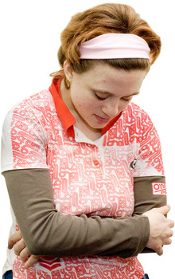

mental health condition

sensory needs

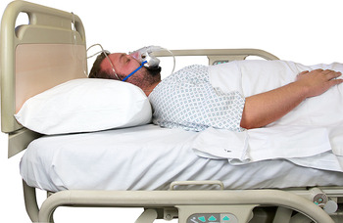
long term illness
Thank you for filling in this feedback form

?

other disability

……………………………………………………..

What is your religion, if you have one? (please tick 1 box only)

What is your sexual preference? (please tick 1 box only)

heterosexual

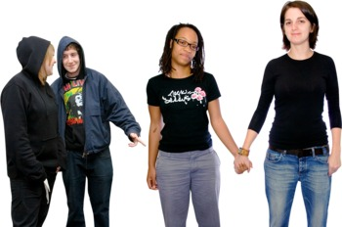

gay or lesbian

bisexual

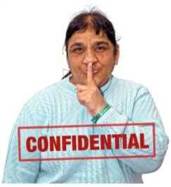

I’d rather not say

Thank you for filling in this questionnaire

Please return this questionnaire to:
Camden SAPB, c/o Performance and Service Improvement,
Adult Social Care, Camden Town Hall, Judd Street, WC1H 9JE

Or email to:
camdenSAPB@camden.gov.uk

