cid:image004.jpg@01C4DDE8.904D1B20

**Camden Council**

**Learning Disabilities Forum**

**meeting**



**we will be talking about**

* Speaking up



* How to get good support

the meeting is on

**Wednesday 19th August 2015**

**Wednesday 19th August 2015**



**6pm - 8pm**

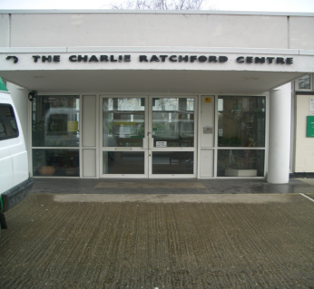

at

**The Charlie Ratchford Resource Centre**

**Belmont Street**

**London, NW1 8HF**



there will be refreshments

buses: 24, 27, 31, 168 and 393.



underground: Chalk Farm Station – Northern Line



cid:image004.jpg@01C4DDE8.904D1B20If you need help to attend the meeting, please phone Giovanni on 02 07 97 45 51 9 before Friday 14th August 2015