
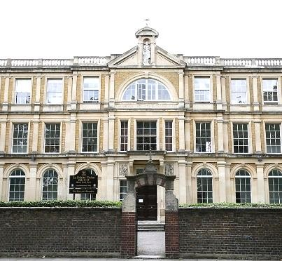
Have your say on the future of La Sainte Union Catholic secondary school


We want to hear your views about the future of La
Sainte Union School - this is called a consultation

A consultation is when we ask people what they think before making a decision



Why we
want to know what you think

There are not as many children starting secondary
school

in the Borough
as there used to be

This means
there are
more
school places than

we
need across
the Borough

Because
La Sainte Union

S
chool

has a lot of
unused school places
,

it is causing money
problems for
the
school

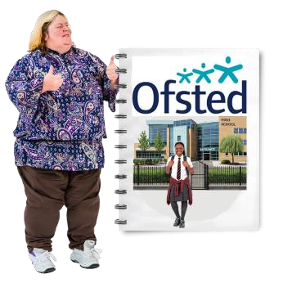
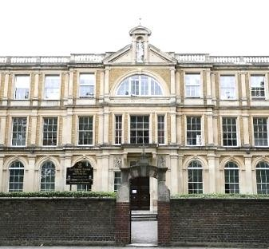
About the school

La Sainte Union is a Catholic girls’ secondary school

Ofsted says the school is good

Ofsted is the organisation that checks how well schools are doing

This consultation is not about the quality of
education, it is about low pupil numbers
and money

Important facts
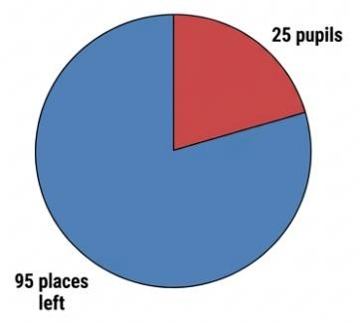
Year 7 had 25 pupils and 120 places
- this means there were lots of empty pupil places

Because there were fewer pupils, the school received less money
- this meant the school had 1.26 million pounds less funding than it needed

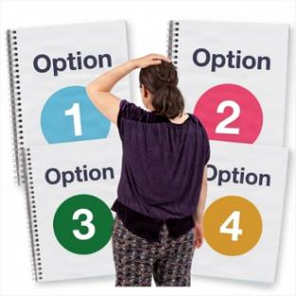
Options being looked at

Option 1: This option would reduce the number of Year 7 places from 120 places to 90 places each year

- there are lots of empty Year 7 places in Camden schools

- this option would reduce Year 7 places from
120 to 90 places each year

- the school is not expected to fill 90 places, so this change is not expected to affect current students

Option 2: Join with another school
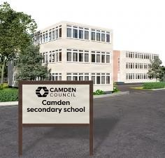
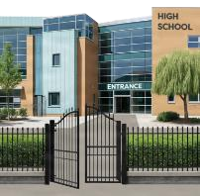
- this option would mean the school works more closely with another school and shares staff and resources

- this could help save money and reduce costs

Option 3: Only keep the sixth form


- this option is being considered because there are very few students in Years 7 to 11, but the sixth form is doing well

- the school could focus on sixth form education only and stop teaching Years 7 to 11

- this could help the school have enough students and money for the future

Option 4: Fully close La Sainte Union School
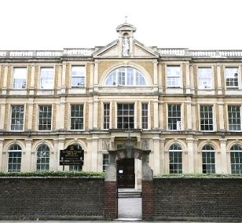

Closed
- this option is being looked at because the school has a lot of empty places and is facing serious money problems

- closing the school would mean fewer empty places in Camden schools and more students at other local schools

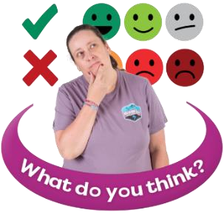
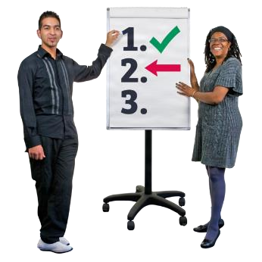
What happens next?

No decision has been made yet

We want to know what you think about each
option, before making a decision



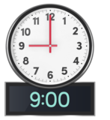


Have your say

You can tell us what you think by
- completing this questionnaire
- emailing your completed questionnaire to lasainteunionconsultation@camden.gov.uk
- posting your completed questionnaire to SSP Consultation
Participation and Partnerships
Floor 5 at 5PS
FREEPOST RUCA–AXAS–ZEUS
London Borough of Camden
Town Hall
London
WC1H 9JE

- please return this questionnaire by
9am on Monday 14 December

Your contact details
(you do not have to answer these questions)
 | your name……………………………………………………….
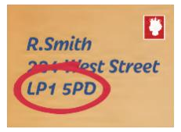 | your address…………………………………………………… ……………………………………………………………………..
 | your telephone number…………………………………….
 | your email address………………………………………….

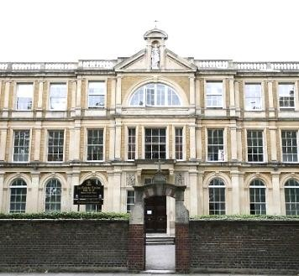
Do
es your child, or your children, go to La Sainte Union School
?

only tick
(
1

box)

yes

no

If you ticked no, please tell us about your interest in the school
For example, you work there, you are a school governor, or live nearby
 | (please tell us here)

Please answer the questions for each option

Option 1
This option would reduce the number of Year 7 places from 120 places to 90 places each year


Do you understand why Camden has suggested this option?
(only tick 1 box)
yes
no


Do you agree with reducing the number of Year 7 places from 120 to 90 each year?
(only tick 1 box)
yes
no

 How would this option affect you, your family, or local community?
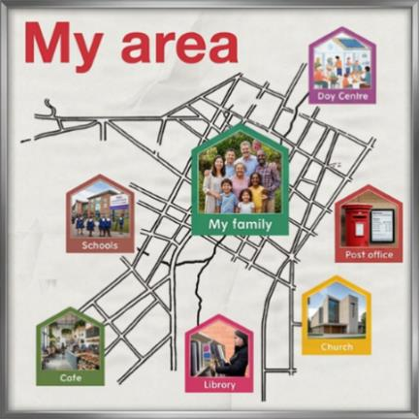 | (please tell us here)

How do you think this option would affect families who want a Catholic school place?
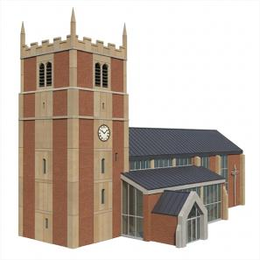 | (please tell us here)


How do you think this option would affect children and young people with Special Educational Needs and Disabilities (SEND)?
 | (please tell us here)

 Do you have any other comments about option 1?
 | (please tell us here)

Option 2
Join with another school
• this option would mean La Sainte Union School would join with another school and share staff and resources


Do you understand why Camden has suggested this option? (only tick 1 box)
yes
no


Do you agree with the option for La Sainte Union joining with another school and sharing leaders?
(only tick 1 box)
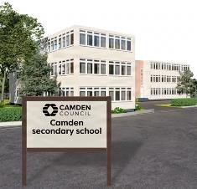 | yes
 | no

 How would this option affect you, your family, or local community?
(please tell us here)


How do you think this option would affect families who want a Catholic school place?
(please tell us here)


How do you think this option would affect children and young people with Special Educational Needs and Disabilities (SEND)?
 | (please tell us here)

 Do you have any other comments about option 2?
 | (please tell us here)
Option 3
Only keep the sixth form
- the school would stop teaching Year 7 to Year 11 students
- the sixth form would stay open and be run with support from another school


Do you understand why Camden has suggested this option?
(only tick 1 box)
yes
no

Do you agree with the option that
- the school should stop teaching Years 7 to 11
- and the sixth form should stay open and be run with support from another school
(only tick 1 box)
yes
no

 How would this option affect you, your family, or local community?
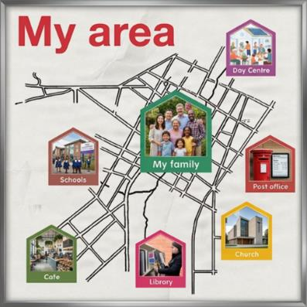 | (please tell us here)

How do you think this option would affect families who want a Catholic school place?
 | (please tell us here)


How do you think this option would affect children and young people with Special Educational Needs and Disabilities (SEND)?
(please tell us here)

 Do you have any other comments about option 3?
 | (please tell us here)

Option 4
Fully close La Sainte Union School
• this option would close La Sainte Union School for all pupils


Do you understand why Camden has suggested this option? (only tick 1 box)
yes
no


Do you agree with the option to fully close La Sainte Union? (only tick 1 box)
 | yes
  
  Closed
 | no

 How would this option affect you, your family, or local community?
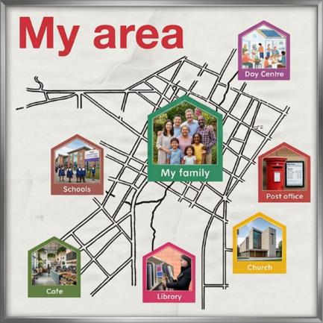 | (please tell us here)


How do you think this option would affect families who want a Catholic school place?
(please tell us here)


How do you think this option would affect children and young people with Special Educational Needs and Disabilities (SEND)?
(please tell us here)

 Do you have any other comments about option 4?
 | (please tell us here)

Other ideas
Do you have any other ideas for the future of La Sainte Union school?
 | (please tell us here)

Remember to return this completed questionnaire by 9am on Monday 14 December, by:

- Returning it to La Sainte Union school
- emailing your completed questionnaire to lasainteunionconsultation@camden.gov.uk
- posting your completed questionnaire to SSP Consultation
Participation and Partnerships
Floor 5 at 5PS
FREEPOST RUCA–AXAS–ZEUS
London Borough of Camden
Town Hall
London
WC1H 9JE

