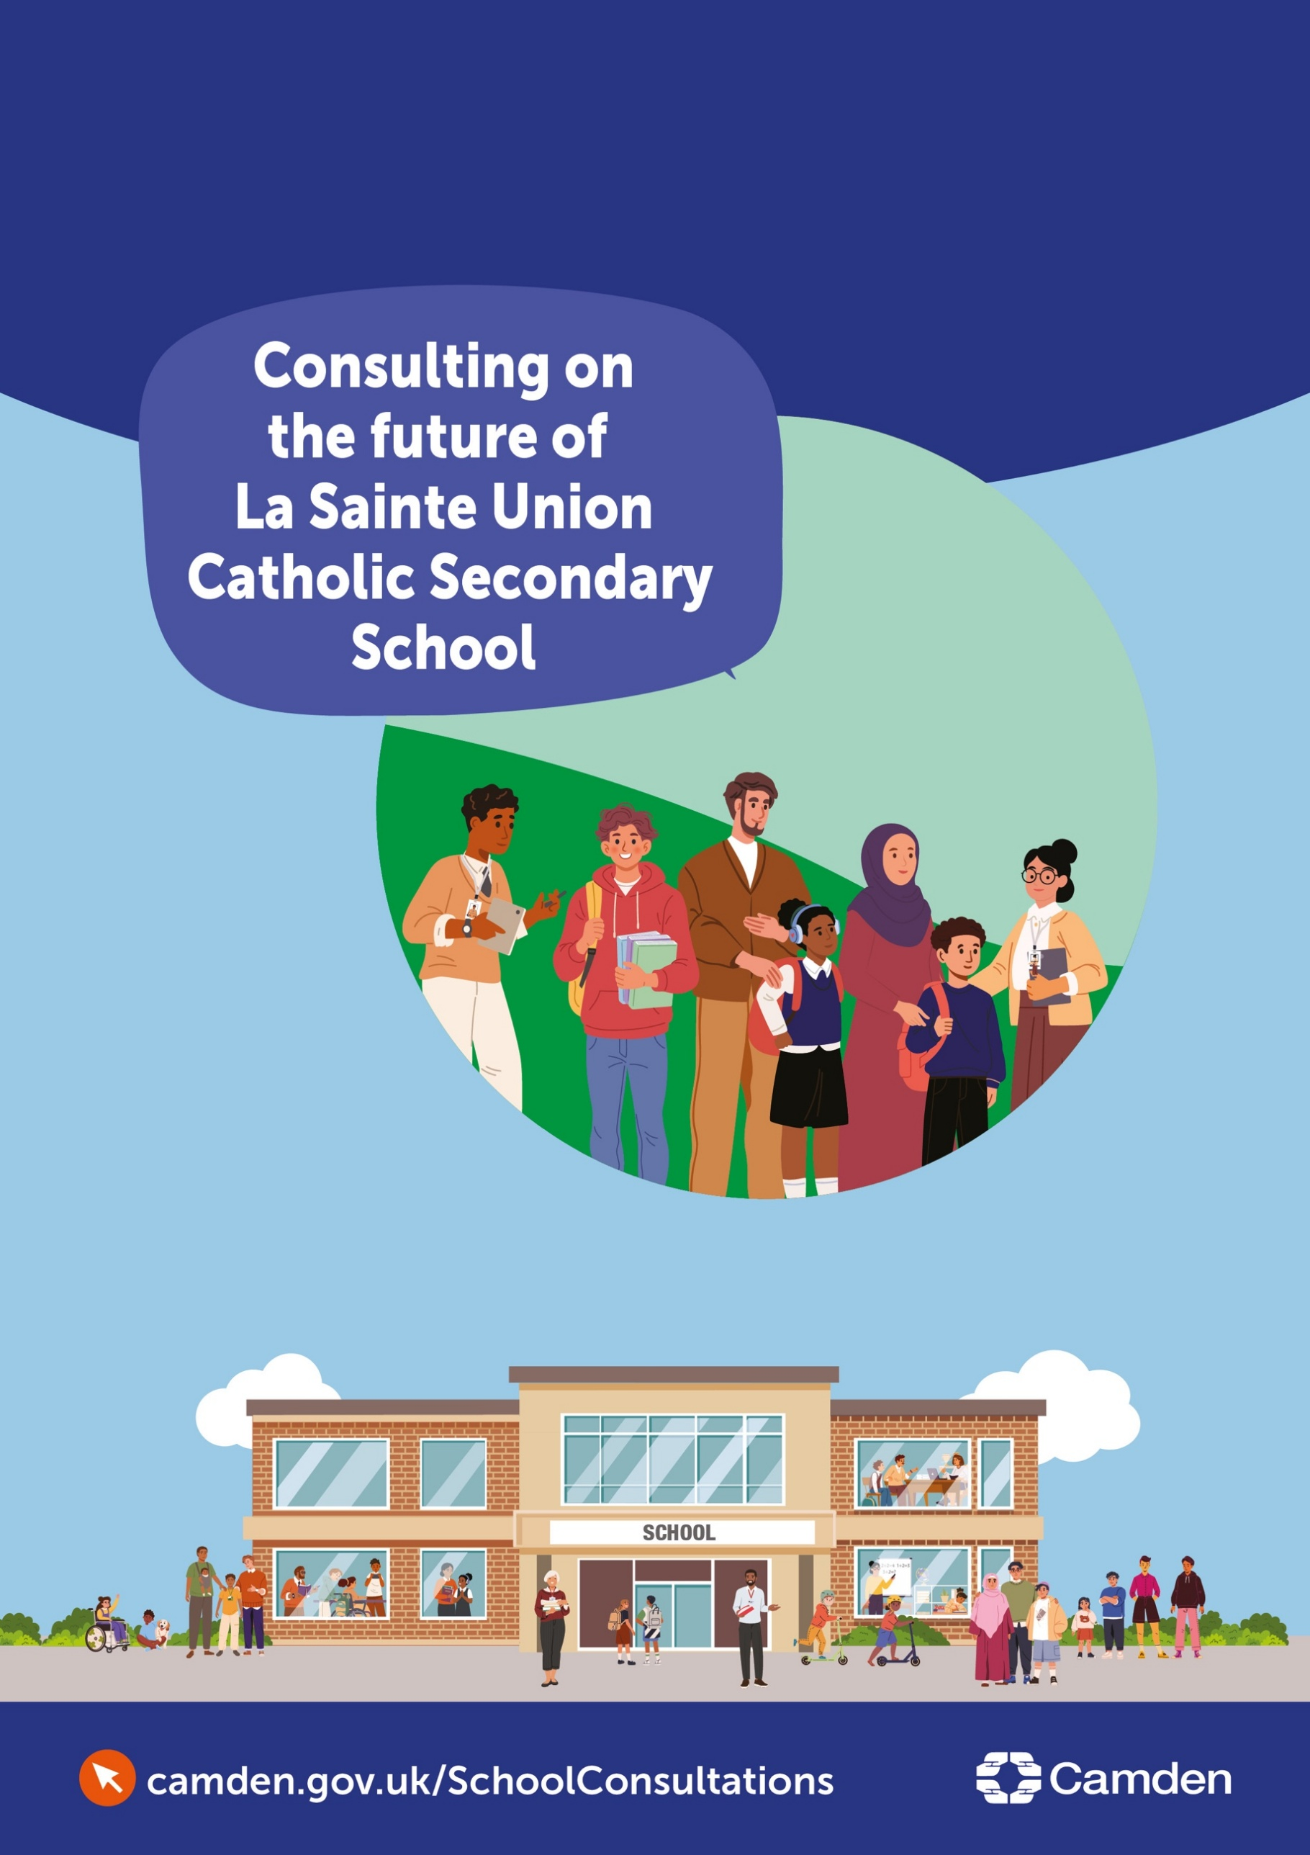
Contents
Consultation on the future of La Sainte Union Catholic Secondary School 1
Introduction 2
Background 2
Detail: the Camden position 3
Option 1: Reduce the Published Admission Number (PAN) from 120 to 90 places 7
Option 2: Federation with another secondary school 7
Option 3: Cease Year 7 to Year 11 school provision, and retain and reconfigure post16 provision (Years 12 – 13/14) 8
Option 4: Full closure of LSU (Year 7 – 14) 9
Have your say 10

Consultation on the future of La Sainte Union Catholic Secondary School

Introduction
Camden Council is seeking the views of parents/carers, staff, the local community and other interested parties on options regarding the future organisation of La Sainte Union Catholic Secondary School (referred to in the rest of the document as LSU). The date on which any changes will take effect will depend on the option ultimately chosen (if it is decided to proceed with any changes).
This is a consultation regarding options for structural change and covers the statutory requirements for consultation under s15 of the Education and Inspections Act 2006.
This document forms the basis of a six-week public consultation and provides information on the reasons for this consultation, as well as asking for your views about it. Please read the document carefully and respond to our short questionnaire at the end before the closing date of 9 am on 14th December 2026.
Our website has information on the consultation and a regularly updated ‘frequently asked questions’ section: www.camden.gov.uk/camden-school-proposals
The local authority will consider all the views put forward during the consultation period. A decision will be taken on the next steps at a future Council Cabinet meeting.

Background

Camden is an excellent place to learn, with high-quality schools and dedicated staff who support children and young people to thrive. The Council’s ambition is that every child has the best start in life and can access a good or outstanding local school place in a setting that is sustainable, inclusive and able to meet their needs.
The Council has a legal duty under sections 13 and 14 of the Education Act 1996 to promote high educational standards, ensure fair access to opportunity in education and training, and ensure there are sufficient schools for primary and secondary education within the borough.
We are committed to ensuring that all children and young people in Camden continue to have access to high-quality education in sustainable and financially viable schools. However, schools in the borough are now facing the reality of having too few pupils to sustain the current number of primary school places.

What are we consulting on?

We have considered a number of options to respond to declining pupil numbers, but there may be others. As well as your views on the options in this document we want to hear if you think there are better options that are not included here.

Following the consultation period we will assess fully the options we have put forward along with any other options which have been identified and use that assessment and other evidence to advise the Council’s Cabinet committee on recommended decisions.
The options we are seeking your views on are:
- Reduce LSU School’s Published Admission Number (PAN)
- Federation with another secondary school
- Cease Year 7 to Year 11 school provision, and retention and reconfiguration of post-16 provision through partnership arrangements (Years 12 – 13/14)
- Full closure of LSU (Year 7 to Year 14)
Each option is described below.

In commenting on the options or proposing new options consultees may wish to be aware of the things we will need to consider when assessing options, as follows.

The assessment of options which do not involve closure of the school will consider whether the option
- Contributes towards reducing the levels of surplus school places in Camden
- Contributes to securing a viable future for the school
- Helps to ensure that current and future pupils will continue to receive a high standard of education in a safe and inclusive environment

The assessment of those options which involve the closure of the school will consider whether closing the school is in line with the requirements of statutory guidance on the closure of maintained schools, in particular addressing the factors set out on pages 21 – 24 of the guidance.

Detail: the Camden position

Camden is experiencing a sustained and pronounced decline in pupil numbers, consistent with trends across Inner London. This is driven by:
- Fewer babies being born: births fell by about 27% between 2015 and 2024.
- Families moving out of the borough.
- Changes in housing, including more short-term rentals and student accommodation.
January 2026
Secondary Schools Year 7 pupil numbers
Camden secondary schools had 1,585 planned school places, but 1,209 pupils. There were 376 empty places (23.7%).
Whole School (Year 7 – 11) pupil numbers
Camden secondary schools had 8,210 planned school places, but 6,974 pupils. There were 1,236 empty places (15%).
Projections for 2032/33
Secondary Schools Year 7 pupil numbers
The projected number of Year 7 secondary school pupils is 1,140. If there are 1,525 planned places, there would be 385 empty places.
Whole School (Year 7 – 11) pupil numbers
The projected number of Year 7 - 11 secondary school pupils is 6,030. If there are 8,150 planned places, there would be 2,120 empty places.
In June 2026, Council officers told the Schools Forum that falling pupil numbers were affecting schools' finances. Total school reserves fell from £14.6 million to £6.5 million in one year. Sixteen schools (31%) were in deficit, and several had large deficits.

Analysis of movement in individual school balances 2025/26 (Extract from Camden School Forum June 2026):
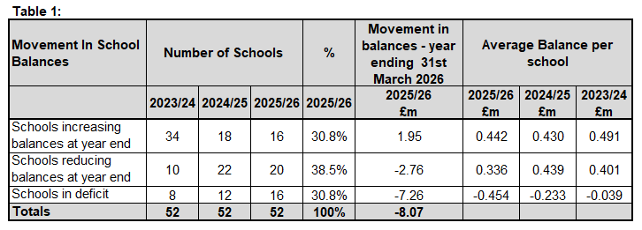

Overall, Camden has more school places than it needs. If this continues, more schools may face financial difficulties, and resources may be spread too thinly, which could affect the quality of education.
Looking ahead
The Greater London Authority forecasts that demand for Year 7 places will stay well below the number of places available up to 2033/34. The chart shows the available Year 7 places (PAN) in Camden, the numbers of pupils in Year 7 classes in Camden (Actual Roll) and the GLA forecasts provided in the last three years (SRP 2024, SRP 2025 and SRP 2026).
The Greater London Authority's projections to 2033/34 indicate that Year 7 demand is expected to remain below available capacity throughout the forecast period:

GLA Camden Forecast: children aged 11 years old (year 7)

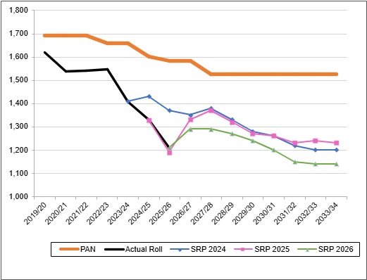

If nothing changes, the Council expects more empty places and more pressure on school budgets. The Council has a legal duty to make sure there are enough good-quality school places, while also supporting fair access and parental choice.
Conclusion
Overall, Camden has more school places than it needs. If this continues, more schools may face financial difficulties, and resources may be spread too thinly, which could affect education quality.
The Cabinet decided on 20th October 2026 to consult on the future of four schools, including LSU. The Cabinet papers can be found at: https://democracy.camden.gov.uk/mgChooseDocPack.aspx?ID=11630

About LSU
Key Facts: LSU
Indicator
Year 7: Places available (2025) | 120
Year 7: Number of pupils (January 2026) | 25
Year 7: Surplus capacity | 79.2%
Year 7 - Year 11: Places available (2025) | 780
Year 7 – Year 11: Number of pupils (January 2026) | 292
Year 7 – Year 11: Surplus capacity | 62.6%
Sixth Form: Number of pupils (January 2026) | 258
School Budget – accumulated reserves at March 2026 | -£1,263,711 deficit
Camden Secondary Schools Year 7: Number of empty places in alternative schools (mixed or girls) (January 2026) | 238
Camden Secondary Schools Year 7 – Year 11: Number of empty places in alternative schools (mixed or girls) (January 2026) | 611

Overview
LSU is a girls’ voluntary-aided Catholic secondary school serving students from Year 7 to Year 13/14, which has been graded as ‘Good’ by Ofsted. The report noted:
The school has high expectations of pupils’ achievement. Pupils are keen to do well, and they are ambitious for their futures. Their successes are reflected in the outcomes they achieve at the end of Year 11. Across the school, pupils and students in the sixth form typically learn well.
The sixth-form provision is mixed-sex. The sixth-form roll is strong and is part of a consortium with three other Camden secondary schools (William Ellis, Acland Burghley, and Parliament Hill schools), all in close proximity to LSU, known as the LaSWAP consortium. The aim of the consortium is to create the best possible post-16 education for students in each of the four schools. Its objectives relate to collaboration in planning and delivery of the curriculum offer, creation of a campus-style experience for post-16 students, and collaboration to deliver excellent quality of provision for all post-16 learners.
LSU is located in Highgate and is easily accessible from central London, served by nearby train stations and bus routes.
LSU is a diverse school, with pupils coming from a range of ethnic backgrounds. It is also inclusive of pupils with disabilities, providing support for pupils with Special Educational Needs and Disabilities (SEND).
Consulting on the future of LSU is not a reflection on the quality of education or staff, but a response to falling pupil numbers and the need to reduce the number of empty school places in the borough.
Reasons for potential change
The Council used the same set of tests to decide which schools may need a major change. It looked at:
- Whether more than half of places at the main entry point are regularly empty.
- Whether the total number of pupils in the school is continuing to fall.
- Whether the school has, or is expected to have, a growing budget deficit.
LSU has been significantly affected by falling pupil numbers, so we are consulting on options to respond to this decline.
The school's financial position is challenging. The school recorded an accumulated deficit balance of £1,263,711 as at March 2026. The school has submitted a budget which shows the position deteriorating to a position where the school’s deficit balance will be more than £6.476 million as at March 2029.
LSU reduced their number of available places from 180 to 120 in September 2024, but are operating well below 120, with 25 children recorded as pupils at LSU for Year 7 in January 2026.
This consultation sets out four options to respond to these challenges. No decision has been made. The Council welcomes consultees putting forward alternative options to secure a sustainable and successful future for LSU.

Option 1: Reduce the Published Admission Number (PAN) from 120 to 90 places
Published Admission Number (PAN) is the term for the number of places a secondary school has available for pupils at Year 7.
Reducing PAN is generally used to help schools’ financial positions where they have a staffing structure designed for a certain number of students but their PAN means that they are admitting additional students, with the result that their expenditure increases more than their income. This does not apply in LSU’s case, where PAN is considerably higher than the number of Year 7 starters, and this has been the case for a number of years.
The governing body is the admissions authority for the school and would be responsible for consulting on any proposal to reduce PAN.
What is suggested?
Reduce the number of Year 7 places LSU normally offers each year from 120 to 90. The earliest the PAN could change is for admission in September 2029. It only affects new starters at the school, so there is no direct impact on students who are already on roll at LSU.
Why is this being considered?
By reducing PAN the overall level of surplus capacity in Year 7 across the borough would reduce from 18.6% to 17.1% (2029/30).
There is no evidence to suggest that numbers taking up a place at LSU will increase in the foreseeable future to 90. Therefore there is not likely to be any impact on the school of reducing the PAN to 90.

Option 2: Federation with another secondary school
A federation is where two or more maintained schools operate under the governance of a single governing body. Each federated school is treated as an individual school, meaning it:
- keeps its existing DfE category and does not gain, lose, or change its religious character through being part of a federation
- continues to have its admissions determined by the appropriate admission authority
- will receive individual budgets, noting that the local authority can allocate this as a single budget share to the federated governing body. Additionally, the federated governing body, upon receiving the delegated budget for all the schools in the federation, can allocate the budget to each individual school or pool all or part of the budget with the agreement of governors.
- is inspected individually by OFSTED
What is suggested?
LSU could seek to form a federation with another maintained school.
This could be with one of the schools in the LaSWAP sixth form consortium with whom LSU already has existing relationships, but does not have to be.
Both schools would have to make separate decisions to form a federation, following the national guidance and regulations.
In developing a proposal for federation, the school would need to engage with the council and the diocese.
There are different governance arrangements that apply to a Roman Catholic voluntary-aided school, such as LSU, on the one hand, and community schools, on the other, that would need to be addressed.
Why is this being considered?
By establishing a federation, schools are sometimes able to identify savings, by sharing staff and resources across two or more schools, which could contribute towards financial efficiencies.

Option 3: Cease Year 7 to Year 11 school provision, and retain and reconfigure post-16 provision (Years 12 – 13/14)
What is suggested?
To close Year 7 – Year 11 provision at LSU School. Pupils would be supported to secure places at alternative schools, with particular attention paid to year 10 students to minimise the impact on their GCSE studies.
To maintain post-16 provision as part of the LaSWAP consortium (LSU, William Ellis, Acland Burghley, and Parliament Hill Schools).
Why is this being considered?
LSU is part of a strong post-16 consortium, with three other local secondary schools. Numbers in the sixth form are strong, being above the 200 regarded by the DfE as the minimum suitable level for cases where a sixth form is to be added to an 11-16 school. This is in contrast to the position in years 7 to 11.

This option would lead the school to focus entirely on 16-18 provision. LSU already recruits students from other schools at year 12, but in this model 100% of its recruitment would have to come from other schools, therefore requiring a substantial shift in marketing effort. Depending on how this was managed this could be potentially destabilising for the other members of the LaSWAP consortium.

LSU would need to develop a credible business plan to support such a major change in provision. Given the impact on the other consortium members, the development of such a plan should be progressed in discussion with them.

The Council's analysis identified that LSU has various viability risk factors:
- Has 79.2% empty places in Year 7
- Is operating at 1 Form of Entry, in Year 7
- Is financially vulnerable with a £1,263,711 deficit
Parents/carers may prefer smaller classes; however, as school funding is per pupil, this may affect the resources available to pupils in the long term. Many Camden secondary schools have been rated as ‘good’ or ‘outstanding’ by Ofsted, so the quality of education for current pupils at LSU will be maintained should the school close. Other schools also have pupils from diverse racial or ethnic backgrounds and experience in providing SEND support to pupils.
Alternative secondary provision
The suitability of alternative schools would depend on where the pupils live and on the unique nature of the school as a girls-only Catholic school.
The Council recognises the important contribution that Catholic schools make to Camden's education system and to the communities they serve. The proposals set out in this consultation are not a reflection on the quality of education provided at LSU, but to address the significant surplus of primary school places in Camden. The Council is committed to working closely with the Diocese and school leaders to consider how access to high-quality Catholic education can be maintained for local families when assessing future options.
Within Camden, the nearest alternative schools for Year 7 to 11 are:
- Parliament Hill (girls only) is about 0.1 miles from LSU, and has an Ofsted rating of ‘Outstanding’
- Acland Burghley (mixed) is about 0.7 miles from LSU, and has an Ofsted rating of ‘Good’

Option 4: Full closure of LSU (Year 7 – 14)
What is suggested?
To close LSU fully, including the post-16 provision. Pupils would be supported to secure places at alternative schools, with particular attention paid to year 10 and year 12 students to minimise the impact on their GCSE and post-16 studies.
Why is this being considered?
The Council’s analysis identified that LSU has various viability risk factors:
- Has 79.2% empty places in Year 7
- Has 62.6% empty places across Years 7 – 11
- Is financially vulnerable with a deficit of over £1.2 million that is forecast by the school to increase beyond £6.476 million by March 2029.
Closing the school would remove 780 secondary Year 7 to Year 11 places from Camden’s overall supply and reduce the number of empty places. The financial position of schools which admitted displaced LSU pupils would improve, helping to protect their future sustainability.
The Council recognises that LaSWAP Sixth Form Consortium is a well-established and valued provider of post-16 education, serving students from Camden and neighbouring boroughs. The consortium's collaborative model enables access to a wide range of academic and vocational courses, helping young people progress successfully to higher education, training and employment. The proposals set out in this consultation are focused on addressing significant surplus school places in 11-16 provision and should not be interpreted as a reflection on the quality, performance or contribution of LaSWAP. This consortium plays an important role in the local education system and will continue to work with partners to support post-16 opportunities for young people, following any of the outcomes from this consultation”
Nearest Alternative Schools in Camden
Within Camden, the nearest alternative schools are:
- William Ellis (boys Year 7 to 11, mixed in sixth form) is about 0.1 miles from LSU, and has an Ofsted rating of ‘Good’
- Parliament Hill (girls Year 7 to 11, mixed in sixth form) is about 0.1 miles from LSU, and has an Ofsted rating of ‘Outstanding’
- Acland Burghley (mixed throughout) is about 0.7 miles from LSU, and has an Ofsted rating of ‘Good’
Alternative sixth-form provision
The following Camden maintained schools have sixth-form provision (years 12 - 14) provision within the current LaSWAP arrangements:
• William Ellis School
• Acland Burghley School
• Parliament Hill School

Have your say

You can respond to the consultation by:
- Filling in our online consultation questionnaire: www.camden.gov.uk/camden-school-proposals
- Emailing the consultation response form to: lasainteunionconsultation@camden.gov.uk
- If you have requested a hard copy of the document, by posting the consultation response form to:
SSP Consultation
Participation and Partnerships
Floor 5 at 5PS
FREEPOST RUCA–AXAS–ZEUS
London Borough of Camden
Town Hall
London
WC1H 9JE

We encourage everyone with an interest in the future of LSU to share their views.

Closing maintained schools – Department for Education, May 2026
La Sainte Union Catholic Secondary School - Open - Find an Inspection Report - Ofsted
https://www.laswap.camden.sch.uk/Who-we-are/index.asp

