

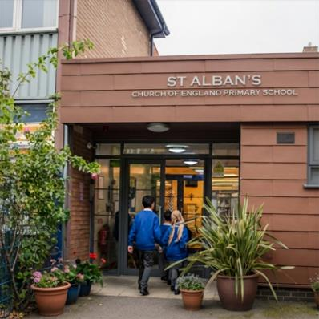
Have your say on the future of St Alban’s Church of England primary school


We want to hear your views about the future of St Alban’s CE Primary School - this is called a consultation

A consultation is when we ask people what they think before making a decision

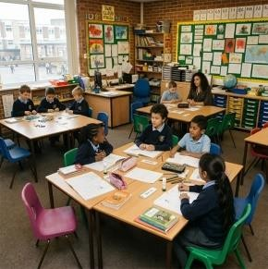

Why we want to know what you think

There are not as many children needing primary
school places in
the Borough as

there used to be

This means there are more school places than we
need across the Borough

Because

there are

lots of un
used
school places
,
the school

gets l
ess money

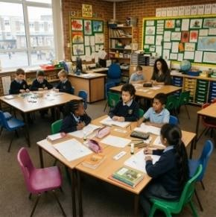
What is happening in Camden?

Not as many
children liv
e

in the area

More school places are empty

We think this will continue
in the future

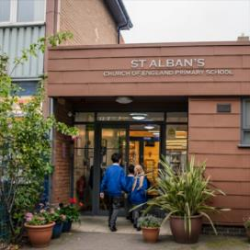

About the school

St Alban’s CE School is a good school and supports all children

But
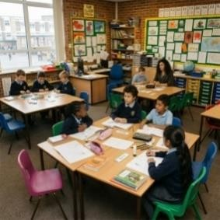

- the number of pupils has gone down

- lots of school places have not been filled
- the school has less money coming in

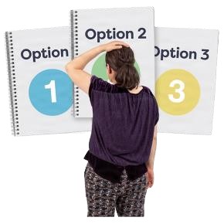
Options being looked at

Option 1: This option would reduce the number of Reception places from 30 pupils to 15 pupils each year

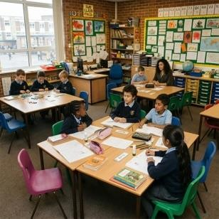
- this option is being looked at because fewer children are starting at the school each year

- reducing the number of Reception places from 30 pupils to 15 pupils each year could help the school organise classes more easily and manage its money better

Option 2: Join with another Camden school

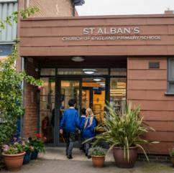
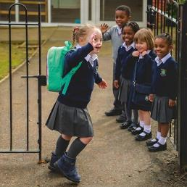
- this option is being considered so that all St Alban’s pupils could move to a new school together - St Alban’s would close

- it would also mean families are offered a place at another school if St Alban’s closes

Option 3: Fully close St Alban’s Church of England School

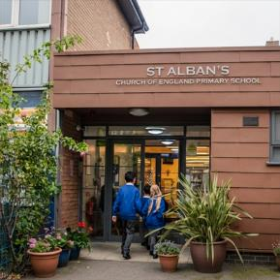

- this option is being considered because the school has fewer children attending each year and is having money problems

- closing the school would mean fewer empty school places in Camden and more children attending other local schools

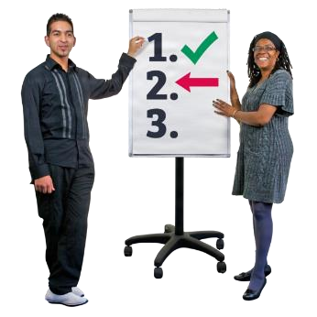
What happens next?

No decision had been made yet


We want to know what you think about each option before deciding

We want to hear from parents, carers, staff, governors, local people and anyone interested in the school

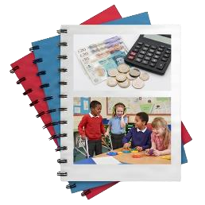

We will look at
- what is best for children
- school money
- the local community
- support for children with SEND (Special Educational Needs and Disabilities)


Have your say

You can tell us what you think by
- completing this questionnaire and returning to St Alban’s School



- emailing your completed questionnaire to stalbansconsultation@camden.gov.uk

- posting your completed questionnaire to
SSP Consultation
Participation and Partnerships
Floor 5 at 5PS
FREEPOST RUCA–AXAS–ZEUS
London Borough of Camden
Town Hall
London
WC1H 9JE

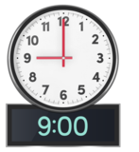

- please return this questionnaire by
9am on Monday 14 December

Your contact details
(you do not have to answer these questions)
 | your name……………………………………………………….
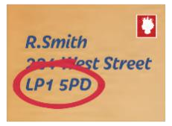 | your address…………………………………………………… ……………………………………………………………………..
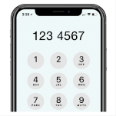 | your telephone number…………………………………….
 | your email address………………………………………….


Does your child, or do your children, go to St Alban’s CE School? (only tick 1 box)
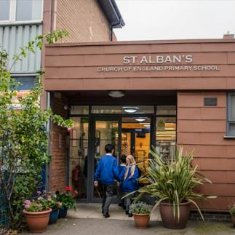 | yes
 | no

If you ticked no, please tell us about your interest in the school
For example, you work there, you are a school governor, or live locally
 | (please tell us here)

Please answer the questions for each option

Option 1
This option would reduce the number of Reception places from 30 pupils to 15 pupils each year


Do you understand why Camden has suggested this option?
(only tick 1 box)
 | yes
 | no


Do you agree with reducing the number of Reception places from 30 pupils to 15 pupils each year?
(only tick 1 box)
yes
no

 How would this option affect you, your family, or local community?
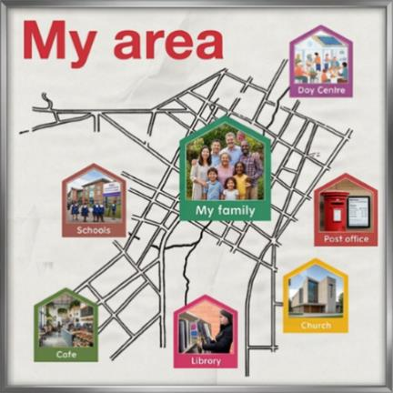 | (please tell us here)


How do you think this option would affect families who want a Church of England school place?
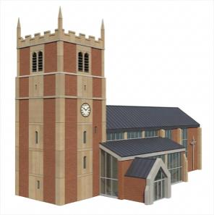 | (please tell us here)


How do you think this option would affect children and young people with SEND (Special Educational Needs and Disabilities)?
 | (please tell us here)

 Do you have any other comments about option 1?
 | (please tell us here)

Option 2
Join with another Camden school
• this option would mean St Alban’s pupils would move to a new school together - St Alban’s School would close


Do you understand why Camden has suggested this option? (only tick 1 box)
yes
no


Do you agree with the option for St Alban’s CE School joining with another school and sharing leaders?
(only tick 1 box)
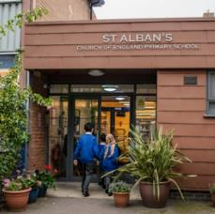 | yes
 | no

 How would this option affect you, your family, or local community?
(please tell us here)


How do you think this option would affect families who want a Church of England school place?
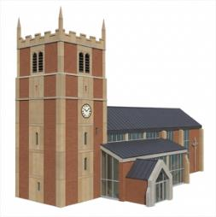 | (please tell us here)


How do you think this option would affect children and young people with SEND (Special Educational Needs and Disabilities)?
 | (please tell us here)

 How would getting to school change for you?
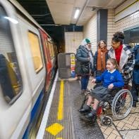 | (please tell us here)

 Do you have any other comments about option 2?
 | (please tell us here)
Option 3
Fully close St Alban’s Church of England School • children would be supported to move to other local schools


Do you understand why Camden has suggested this option?
(only tick 1 box)
yes
no


Do you agree with the option
to fully close St Alban’s

CE School?

only tick
(
1

box)

yes

no

 How would this option affect you, your family, or local community?
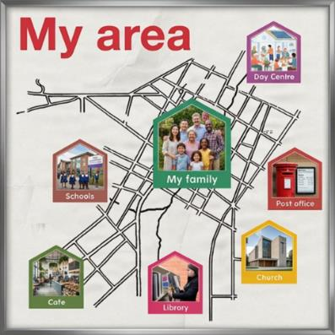 | (please tell us here)


How do you think this option would affect families who want a Church of England school place?
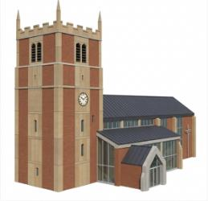 | (please tell us here)


How do you think this option would affect children and young people with SEND (Special Educational Needs and Disabilities)?
 | (please tell us here)

 How would getting to school change for you?
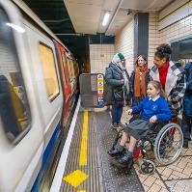 | (please tell us here)

 Do you have any other comments about option 3?
 | (please tell us here)

Other ideas
Do you have any other ideas for the future of St Alban’s CE School?
 | (please tell us here)

Remember to return this completed questionnaire by 9am on Monday 14 December by:

- completing this questionnaire and returning to St Alban’s School

- emailing your completed questionnaire to stalbansconsultation@camden.gov.uk

- posting your completed questionnaire to
SSP Consultation
Participation and Partnerships
Floor 5 at 5PS
FREEPOST RUCA–AXAS–ZEUS
London Borough of Camden
Town Hall
London
WC1H 9JE

