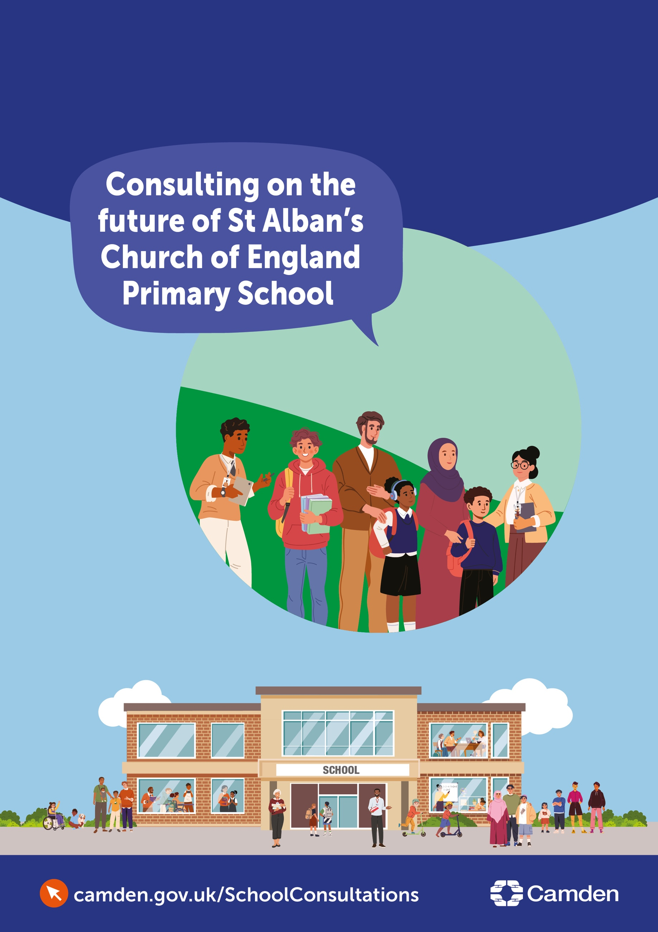
Contents
Introduction 2
Background 2
What are we consulting on? 2
Detail: the Camden position 3
About St Alban’s CE Primary School 5
Option 1: Reduce the Published Admission Number (PAN) 7
Option 2: Amalgamate St Alban’s with another primary school, through closing St Alban’s and transferring pupils to that school 7
Option 3: Close St Alban’s CE Primary School 8
Have your say 9

Consultation on the future of St Alban’s Church of England Primary School

Introduction
Camden Council is seeking the views of parents/carers, staff, the local community and other interested parties on options regarding the future organisation of St Alban’s Church of England (CE) Primary School. The date on which any changes will take effect may vary depending on which option is ultimately chosen (if it is decided to proceed with any changes).
This is a consultation regarding options for structural change and covers the statutory requirements for consultation under s15 of the Education and Inspections Act 2006.
This document forms the basis of a six-week public consultation and provides information on the reasons for this consultation, as well as asking for your views about it. Please read the document carefully and respond to our short questionnaire at the end before the closing date of 9 am on 14th December 2026.
Our website has information on the consultation and a regularly updated ‘frequently asked questions’ section: www.camden.gov.uk/camden-school-proposals
The local authority will consider all the views put forward during the consultation period. A decision will be taken on the next steps at a future Council Cabinet meeting.

Background
Camden is an excellent place to learn, with high-quality schools and dedicated staff who support children and young people to thrive. The Council’s ambition is that every child has the best start in life and can access a good or outstanding local school place in a setting that is sustainable, inclusive and able to meet their needs.

The Council has a legal duty under sections 13 and 14 of the Education Act 1996 to promote high educational standards, ensure fair access to opportunity in education and training, and ensure there are sufficient schools for primary and secondary education within the borough.
We are committed to ensuring that all children and young people in Camden continue to have access to high-quality education in sustainable and financially viable schools. However, schools in the borough are now facing the reality of having too few pupils to sustain the current number of primary school places.

What are we consulting on?
We have considered a number of options to respond to declining pupil numbers, but there may be others. As well as your views on the options in this document we want to hear if you think there are better options that are not included here.

Following the consultation period we will assess fully the options we have put forward along with any other options which have been identified and use that assessment and other evidence to advise the Council’s Cabinet committee on recommended decisions.

The options we are seeking your views on are:
- Reduce St Alban’s CE Primary School Reception Published Admission Number (PAN) from 30 to 15 pupils
- Amalgamate St Alban's CE Primary School with another Camden primary school, and close St Alban’s CE Primary School as a separate legal entity
- Close St Alban’s CE Primary School

Each option is described below.

In commenting on the options or proposing new options consultees may wish to be aware of the things we will need to consider when assessing options, as follows.

The assessment of options which do not involve closure of the school will consider whether the option
- Contributes towards reducing the levels of surplus school places in Camden
- Contributes to securing a viable future for the school
- Helps to ensure that current and future pupils will continue to receive a high standard of education in a safe and inclusive environment

The assessment of those options which involve the closure of the school will consider whether closing the school is in line with the requirements of statutory guidance on the closure of maintained schools, in particular addressing the factors set out on pages 21 – 24 of the guidance.

Detail: the Camden position
Camden is experiencing a sustained and pronounced decline in pupil numbers, consistent with trends across Inner London. This is driven by:
- Fewer babies being born: births fell by about 27% in Camden between 2015 and 2024.
- Families moving out of the borough.
- Changes in housing, including more short-term rentals and student accommodation.
The number of children in primary schools across London continues to decline and is projected to reduce further over the next decade. In Camden, the impact of this is evident in the number of pupils in schools.
September 2026
1,302 Reception places were offered to children. This was 5.4% fewer than the year before. In 2025/26, Camden primary schools were using about 85.6% of their available places, compared to our guideline target of 90% to 95%. This means that not every school will be full, so that the school system can accommodate pupils moving into the area, and so that there is scope for parents to have a realistic range of options when applying for a school place for their child.
January 2026
Across whole schools: Reception to Year 6
Camden primary schools had 10,658 planned places but 9,124 pupils. This meant that about 14% of places were empty. By 2032/33, the Council forecasts around 8,450 primary pupils and about 10,613 planned places, which would mean around 20% of places could be empty.
Across Reception
There were 1,460 planned places and 1,312 pupils in January 2026, so about 10% of Reception places were empty.
Looking ahead
The Greater London Authority forecasts that demand for Reception places will stay well below the number of places available up to 2032/33. The chart below shows the available Reception places (PAN) in Camden, the numbers of pupils in Reception classes in Camden (Actual Roll) and the GLA forecasts provided in the last three years (SRP 2024, SRP 2025 and SRP 2026).

GLA Camden Forecast: children aged 4 years old/reception
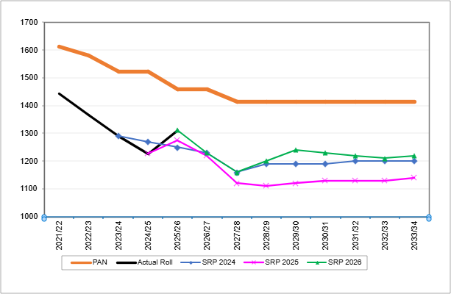

If nothing changes, the Council expects more empty places and more pressure on school budgets. The Council has a legal duty to ensure there are enough good-quality school places while also supporting fair access and parental choice.
Impact on schools
Schools receive much of their funding based on the number of pupils they have. When pupil numbers fall, income falls too, but many costs (such as buildings and staffing) do not fall at the same rate.
In June 2026, Council officers told the Schools Forum that falling pupil numbers were affecting schools' finances. Total school reserves fell from £14.6 million to £6.5 million in one year. Sixteen schools (31%) were in deficit, and several had large accumulated deficit balances.
Analysis of movement in individual school balances 2025/26 (Extract from Camden School Forum June 2026):
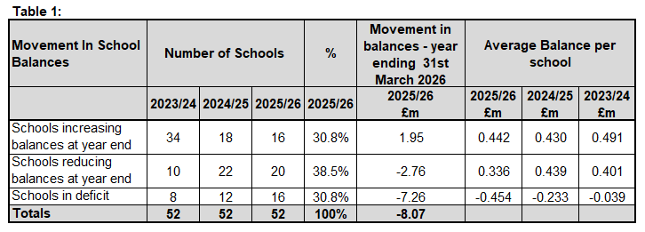

Conclusion
Overall, Camden has more school places than it needs. If this continues, more schools may face financial difficulties, and resources may be spread too thinly, which could affect education quality.
The Cabinet decided on 20th October 2026 to consult on the future of four schools, including St Alban's. The Cabinet papers can be found at: https://democracy.camden.gov.uk/mgChooseDocPack.aspx?ID=11630

About St Alban’s CE Primary School
Key Facts: St Alban’s CE Primary School
Reception: Places available (2025) | 30
Reception: Number of pupils (January 2026) | 13 pupils
Reception: Surplus capacity | 56.7%
Reception - Year 6: Places available (2025) | 210
Reception – Year 6: Number of pupils (January 2026) | 75 pupils
Reception – Year 6: Surplus capacity | 64.3%
School Budget – accumulated reserves as at March 2026 | -£99,419 deficit
Planning Area* | Planning Area 5 (PA5)
PA5 empty places in alternative schools: Reception – Year 6 (January 2026) | 239
* Camden is divided into five planning areas for the purposes of reporting on school places and numbers on roll.
Overview
St Alban’s is a one-form entry Church of England (CoE) voluntary-aided primary school for children aged 3–11.
St Alban’s is located in Holborn and is easily accessible from across central London, served by nearby underground stations, bus routes, and walking and cycling routes. Other schools nearby include Christopher Hatton Primary School, St George the Martyr Church of England Primary School, and St Joseph’s Catholic Primary School.
The school serves the local community, whose diversity is reflected in the many faiths and languages of its pupils. It is also inclusive of pupils with disabilities, providing support for pupils with Special Educational Needs and Disabilities (SEND).
St Alban’s has been rated as ‘Good’ by Ofsted. The report highlighted that pupils had described St Alban’s as a ‘family’ and a ‘caring community’. It talks about the broad curriculum St Alban’s provides and the staff's relentless efforts to remove any barriers to pupils’ learning that may exist.
The school should be commended for the great outcomes for children despite significantly high proportions of SEND need and children who are particularly vulnerable.
Camden, however, is a great place to educate children, and all of Camden’s primary schools are ‘good’ and ‘outstanding’ as per the former Ofsted framework. Therefore, all children are guaranteed to be offered a place at, at least a ‘good’ school, if the school were to be closed.
Consulting on the future of St Alban’s School is not a reflection on the quality of education or staff, but a response to falling pupil numbers and the need to reduce the number of empty school places in the borough.
Reasons for potential change
The Council used the same set of tests to decide which schools may need a major change. It looked at:
- Whether more than half of places at the main entry point are regularly empty.
- Whether the total number of pupils in the school is continuing to fall.
- Whether the school has, or is expected to have, a growing budget deficit.
St Alban's has been significantly affected by falling pupil numbers, so we are consulting on options to respond to this decline.
St Alban’s recorded the highest vacancy rate, across the school, of any Camden primary school in the January 2026 census and the third highest vacancy rate in Reception.
This is impacting St Alban’s budget. The school recorded an accumulated deficit balance of £99,419 as at March 2026, around 6% of its annual budget. If pupil numbers keep falling, the school is expected to face more financial pressure, although the school has submitted a budget which shows the position improving to an accumulated surplus balance of £37,000 as at March 2029. If the school were full its budget would be more than £1 million higher each year.
This consultation sets out three options to respond to these challenges. No decision has been made. The Council welcomes consultees putting forward alternative options to secure a sustainable and successful future for St Alban’s.

Option 1: Reduce the Published Admission Number (PAN)
Published Admission Number (PAN) is the term for the number of places a primary school has available for pupils at Reception. The governing body is the admissions authority for the school and would be responsible for consulting on any proposal to reduce PAN.
Most primary schools in Camden operate with a PAN of 30, meaning that they run one class per year group. Reducing PAN can be used to help schools’ financial positions.
For example a school with a PAN of 60 which usually has 34 pupils starting reception each year would have to run two reception classes, each with 17 pupils. If it reduced its PAN to 30 it would only be able to admit 30 pupils and could therefore run one reception class, thus reducing their costs and improving their financial position.
What is suggested?
Reduce the number of Reception places St Alban's normally offers each year from 30 to 15. This would change the school from 1 form of entry (30 pupils in Reception) to 0.5 form of entry (15 in Reception). The earliest the PAN could change is September 2029. It only affects new starters at the school, so there is no direct impact on pupils who are already on roll in other year groups.
Schools that operate with a PAN of 15 often run a combined nursery/reception class, with mixed classes for Years 1 and 2, Years 3 and 4, Years 5 and 6. If a school continues with small classes that do not combine year groups it is challenging to achieve financial sustainability.
Why is this being considered?
The school is already admitting fewer than half the pupils it has space for in Reception. Forecasts suggest demand is unlikely to return to previous levels in the foreseeable future. By fixing the admission limit at 15 the school could confidently operate with mixed classes in Y1/Y2, Y3/Y4, Y5/Y6 (each with a maximum of 30 pupils), safe in the knowledge that, if numbers did increase, they would be able to operate the mixed year group structure that they are implementing as part of their deficit recovery plan.
As well as providing this financial protection for the school, moving to a PAN of 15 would also improve the borough’s overall level of surplus school places.
Operating with a maximum of 15 pupils in each year group would mean that the school would have substantially reduced levels of funding compared to a position where they were full in all year groups. The school leadership would have to develop a credible plan for operating this model within the available funding.

Option 2: Amalgamate St Alban’s with another primary school, through closing St Alban’s and transferring pupils to that school
Amalgamation is the term for when two or more separate schools join together to become one single school. They share one name, one leader, and one budget. Amalgamation involves one school closing and all its pupils being offered a place at the other school.
Potential receiving schools would be assessed against available capacity, educational quality, accessibility, ability to accommodate pupils with SEND and access to Church of England provision
Parents do not have to take up the place at the other school – they can opt to find an alternative school.
What is suggested?
Amalgamate St Alban's CE Primary School with another primary school. St Alban's would close as a separate school, and pupils currently at St Alban's would be placed at the other school. At this stage no specific school has been identified as a potential school to which St Alban’s pupils would transfer.
Why is this being considered?
Amalgamation ensures that all pupils from the closing school transfer together to the receiving school.
It also means that parents do not have to investigate alternative schools for their children as they are guaranteed places at the receiving school.
Note: This option is only realistic if, at the point that the decision to amalgamate is taken, the receiving school can confidently confirm that they will be able to accommodate all pupils displaced from St Alban’s.

Option 3: Close St Alban’s CE Primary School
What is suggested?
Close St Alban's CE Primary School. Pupils would be supported to apply for places at other schools.
Why is this being considered?
The Council's analysis identified several risks to the school's long-term future:
- 56.7% of Reception places are empty.
- The number of pupils at the whole school (Reception to Year 6) has fallen to around 75 pupils.
- The school has an accumulated budget deficit balance of £99,000 as at March 2026.
- The school is in Planning Area 5, where there are already many empty school places within a reasonable distance of St Alban’s.
Closing the school would remove 210 primary school places from Camden’s overall supply and reduce the number of empty places.
Planning Area 5 had the highest level of empty places across Reception to Year 6 in January 2025/26. Numbers are forecast to fall further, with empty places forecast to rise to 26% by 2032.
Nearest Alternative Schools in Camden
- Christopher Hatton is about 0.3 miles from St Alban's, and has an Ofsted rating of ‘Outstanding’
- St George the Martyr is the nearest Church of England school, about 0.4 miles from St Alban's, and has an Ofsted rating of ‘Outstanding’

Have your say

You can respond to the consultation by:
- Filling in our online consultation questionnaire: www.camden.gov.uk/camden-school-proposals
- Emailing the consultation response form to: stalbansconsultation@camden.gov.uk
- If you have requested a hard copy of the document, by posting the consultation response form to:
SSP Consultation
Participation and Partnerships
Floor 5 at 5PS
FREEPOST RUCA–AXAS–ZEUS
London Borough of Camden
Town Hall
London
WC1H 9JE

We encourage everyone with an interest in the future of St Alban’s to share their views.

Closing maintained schools – Department for Education, May 2026
St Alban's Church of England Primary School - Ofsted

