
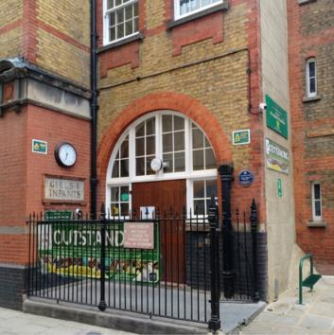
Have your say on the future of St Joseph’s Catholic primary school

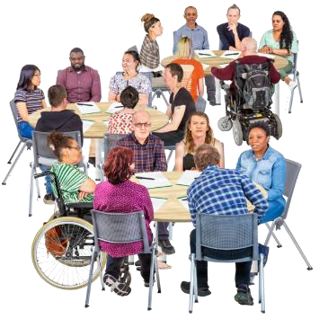
We want to hear your views about the future of St Joseph’s Catholic Primary School - this is called
a consultation

A consultation is when we ask people what they think before making a decision


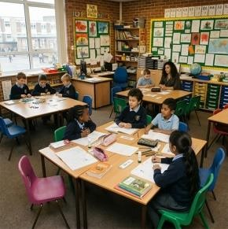


Why we want to know what you think

There are not as many children needing primary
school places in the Borough as there used to be

This means there are more school places than we need across the Borough

Because there are lot of unused school places, the school gets less money

About the school
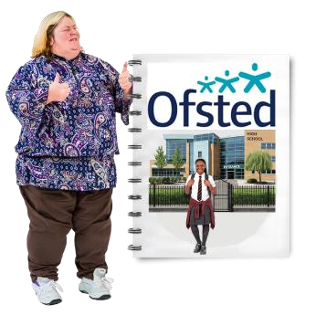

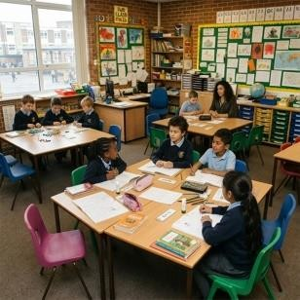
St Joseph’s is a Catholic primary school in Holborn

Ofsted says the school is outstanding Ofsted is the organisation that checks how well schools are doing

This consultation is not about the quality of
education, it is about low pupil numbers and money

But
- Reception has 11 children and 30 places

- the school has 117 pupils and 210 places

- because there are a lot of unused school places, the school gets less money

- the school spends more than it gets and needs about 537 thousand pounds more each year
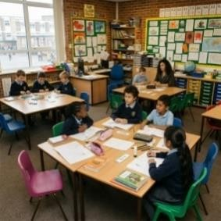



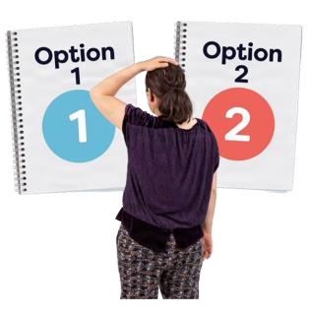
Options being looked at

Option 1: This option would reduce the number of Reception places from 30 pupils to 15 pupils each year

- this option is being considered because fewer children are starting at the school each year

- reducing the number of Reception places from 30 pupils to 15 pupils each year could help the school organise classes more easily and manage its money better

Option 2: Fully close St Joseph’s Catholic Primary School

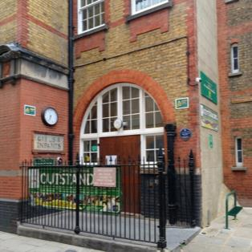

- this option is being considered because the school has fewer children attending each year and is having money problems

- closing the school would mean fewer empty places in Camden and more children attending other local schools

- children will be supported to apply for places at other schools

What happens next?
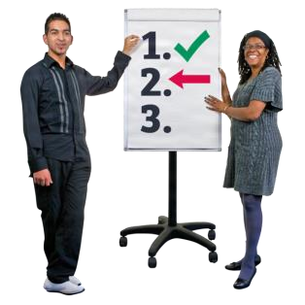
No decision has been made yet

We want to know what you think about each option
before deciding



We want to hear from parents, carers, staff, governors, local people and anyone interested in the school

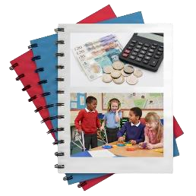

We will look at
- what is best for children
- school money
- the local community
- support for children with SEND (Special Educational Needs and Disabilities)

Have your say


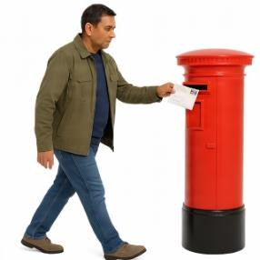
You can tell us what you think by
- completing this questionnaire and returning it to St Joseph’s Catholic Primary School

- emailing your completed questionnaire to stjosephsconsultation@camden.gov.uk

- posting your completed questionnaire to
SSP Consultation
Participation and Partnerships
Floor 5 at 5PS
FREEPOST RUCA–AXAS–ZEUS
London Borough of Camden
Town Hall
London
WC1H 9JE

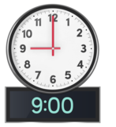

- please return this questionnaire by
9am on Monday 14 December

Your contact details
(you do not have to answer these questions)
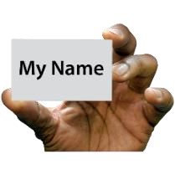 | your name……………………………………………………….
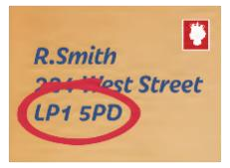 | your address…………………………………………………… ……………………………………………………………………..
 | your telephone number…………………………………….
 | your email address………………………………………….


Does your child, or do your children, go to St Joseph’s
Catholic School?
(only tick 1 box)
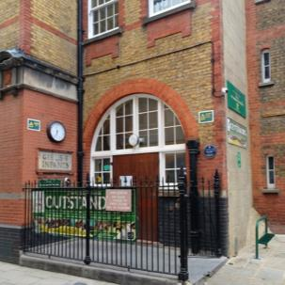 | yes
 | no

If you ticked no, please tell us about your interest in the school
For example, you work there, you are a school governor, or live locally
 | (please tell us here)
Please answer the questions for each option

Option 1
This option would reduce the number of Reception places from 30 pupils to 15 pupils each year


Do you understand why Camden has suggested this option? (only tick 1 box)
yes
no


Do you agree with reducing the number of Reception places from 30 pupils to 15 pupils each year?
(only tick 1 box)
yes
no

 How would this option affect you, your family, or local community?
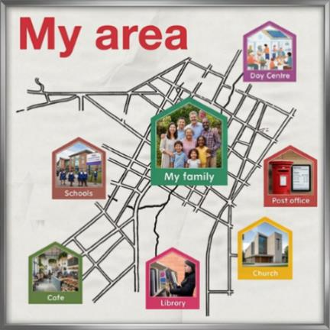 | (please tell us here)

How do you think this option would affect families who want a Catholic school place?
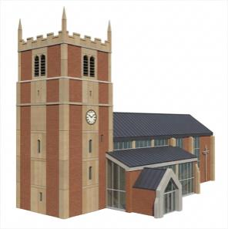 | (please tell us here)


How do you think this option would affect children and young people with SEND (Special Educational Needs and Disabilities)?
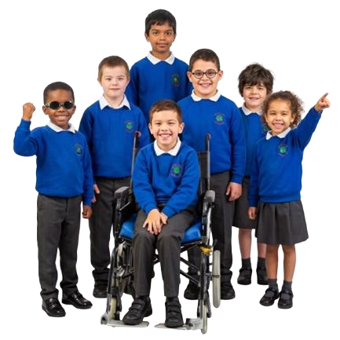 | (please tell us here)

 Do you have any other comments about option 1?
 | (please tell us here)

Option 2
Fully close St Joseph’s Catholic Primary School
• children would be supported to move to another local school


Do you understand why Camden has suggested this option? (only tick 1 box)
yes
no


Do you agree with the option to fully close St Joseph’s Catholic School?
(only tick 1 box)

yes
no

 How would this option affect you, your family, or local community?
(please tell us here)


How do you think this option would affect families who want a Catholic school place?
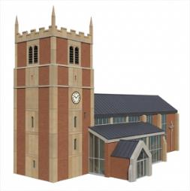 | (please tell us here)


How do you think this option would affect children and young people with SEND (Special Educational Needs and Disabilities)?
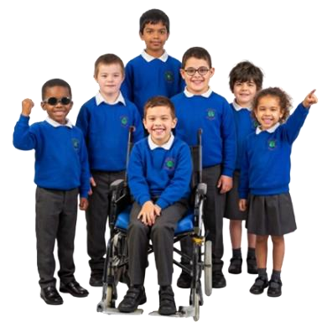 | (please tell us here)

 Do you have any other comments about option 2?
 | (please tell us here)

Other ideas
Do you have any other ideas for the future of St Joseph’s Catholic School?
 | (please tell us here)

Remember to return this completed questionnaire by 9am on Monday 14 December by:

You can tell us what you think by
- completing this questionnaire and returning it to St Joseph’s Catholic Primary School

- emailing your completed questionnaire to stjosephsconsultation@camden.gov.uk

- posting your completed questionnaire to
SSP Consultation
Participation and Partnerships
Floor 5 at 5PS
FREEPOST RUCA–AXAS–ZEUS
London Borough of Camden
Town Hall
London
WC1H 9JE

