

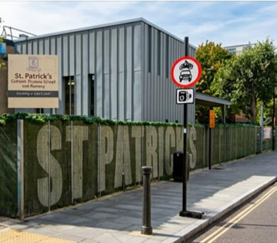
Have your say on the future of St Patrick’s Catholic Primary School


We want to hear your views about the future of St Patrick’s Catholic Primary School - this is called a
consultation

A consultation is when we ask people what they think before making a decision



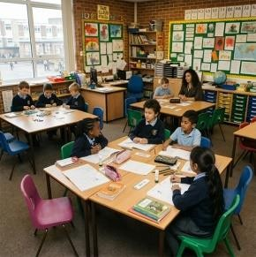


Why we want to know what you think

There are not as many children needing primary
school places in the Borough as there used to be

This means there are more school places than we need across the Borough

Because there are a lot of unused school places, the school gets less money

About the school

St Patrick’s is a Catholic primary school in
Kentish Town
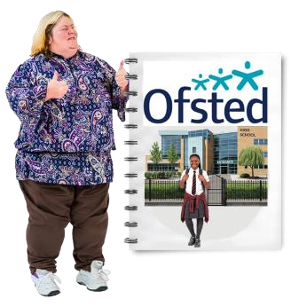

Ofsted says the school is good
Ofsted is the organisation that checks how well schools are doing


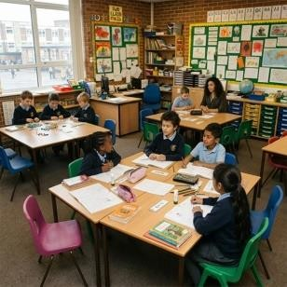
This consultation is not about the quality of
education, it is about low pupil numbers and money

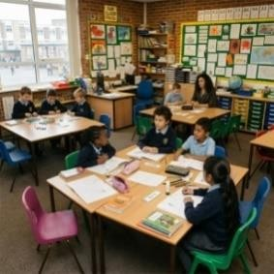
- Reception has 11 children and 30 places
But
- the school has 105 pupils and 210 places

- because there are lots of unused school places, the school gets less money


- the school needs about 330 thousand pounds more each year

Options being looked at

Option 1: Reduce the number of Reception places from 30 pupils to 15 pupils each year
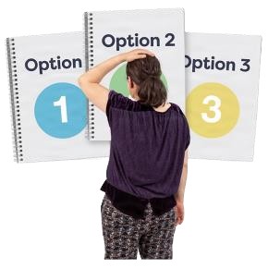
- this option is being considered because fewer children are starting at the school each year

- reducing the number of Reception places from 30 pupils to 15 pupils each year could help the school organise classes more easily and manage its money better

Option 2: Join with another Camden school

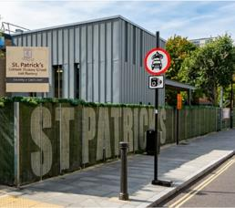
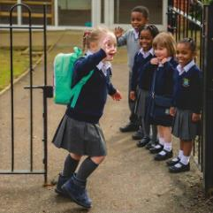
- this option is being considered so that all St Patrick’s pupils could move to a new school together - St Patrick’s would close

- it would also mean families are offered a place at another school if St Patrick’s closes

Option 3: Fully close St Patrick’s Catholic Primary School


- this option is being considered because the school has fewer children attending each year and is having money problems
- closing the school would mean fewer empty school places in Camden and more children attending other local schools
      - children would be supported to move to other local schools

What happens next?
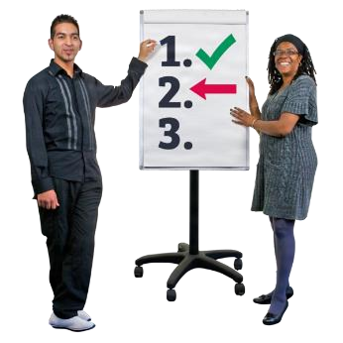
No decision had been made yet

We want to know what you think about each option before deciding
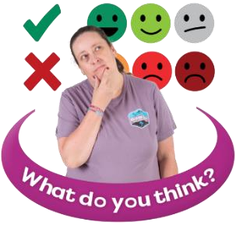
We want to hear from parents, carers, staff, governors, local people and anyone interested in the school

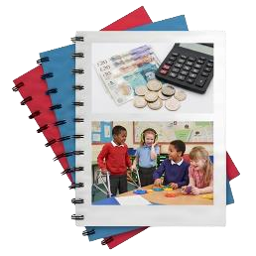

We will look at
- what is best for children
- school money
- the local community
- support for children with SEND (Special Educational Needs and Disabilities)

Have your say

You can tell us what you think by
- completing this questionnaire and returning to
St Patrick’s Catholic Primary School



- emailing your completed questionnaire to stpatricksconsultation@camden.gov.uk

- posting your completed questionnaire to
SSP Consultation
Participation and Partnerships
Floor 5 at 5PS
FREEPOST RUCA–AXAS–ZEUS
London Borough of Camden
Town Hall
London
WC1H 9JE

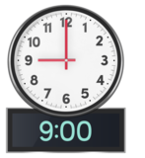

- please return this questionnaire by

9am on Monday 14 December

Your contact details
(you do not have to answer these questions)
 | your name……………………………………………………….
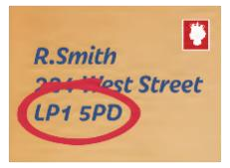 | your address…………………………………………………… ……………………………………………………………………..
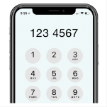 | your telephone number…………………………………….
 | your email address………………………………………….


Does your child, or do your children, go to St Patrick’s Catholic Primary School?
(only tick 1 box)
yes
no

If you ticked no, please tell us about your interest in the school
For example, you work there, you are a school governor, or live locally
 | (please tell us here)

Please answer the questions for each option

Option 1
This option would reduce the number of Reception places from 30 pupils to 15 pupils each year


Do you understand why Camden has suggested this option? (only tick 1 box)
yes
no


Do you agree with reducing the number of Reception places from 30 pupils to 15 pupils each year?
(only tick 1 box)
 | yes
 | no
How would this option affect you, your family, or local community?
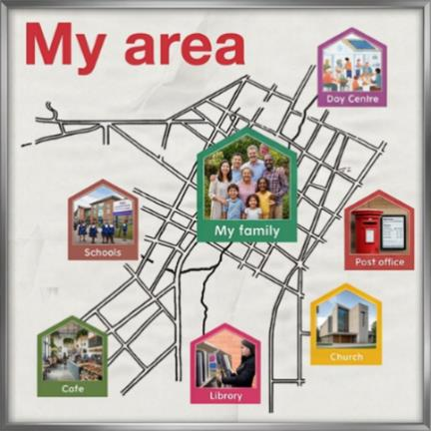 | (please tell us here)


How do you think this option would affect families who want a Catholic school place?
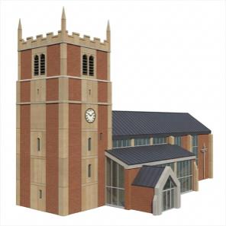 | (please tell us here)


How do you think this option would affect children and young people with SEND (Special Educational Needs and Disabilities)?
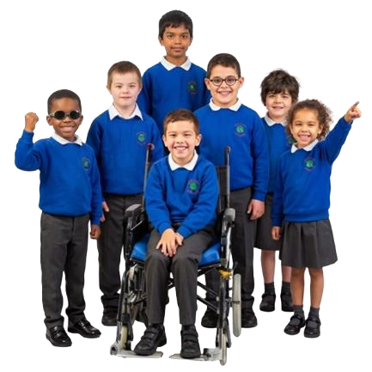 | (please tell us here)

 Do you have any other comments about option 1?
 | (please tell us here)

Option 2
Join with another Camden school
• this option would mean St Patrick’s School pupils would move to a new school together - St Patrick’s School would close


Do you understand why Camden has suggested this option? (only tick 1 box)
yes
no


Do you agree with the option for St Patrick’s School joining with another school and sharing leaders?
(only tick 1 box)
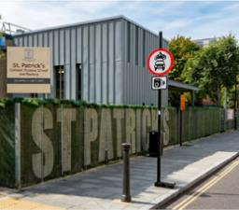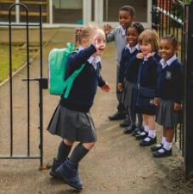 | yes
 | no

 How would this option affect you, your family, or local community?
(please tell us here)


How do you think this option would affect families who want a Catholic school place?
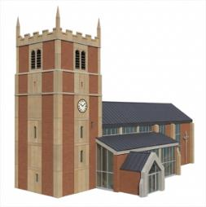 | (please tell us here)


How do you think this option would affect children and young people with SEND (Special Educational Needs and Disabilities)?
 | (please tell us here)
 How would getting to school change for you?
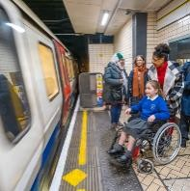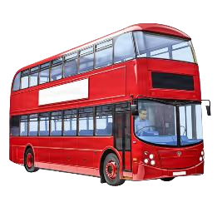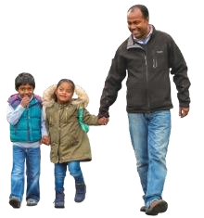 | (please tell us here)

 Do you have any other comments about option 2?
 | (please tell us here)

Option 3
Fully close St Patrick’s Catholic Primary School • children would be supported to move to other local schools


Do you understand why Camden has suggested this option? (only tick 1 box)
yes
no


Do you agree with the option to fully close St
Patrick’s
School?

only tick
(
1

box)

yes

no

 How would this option affect you, your family, or local community?
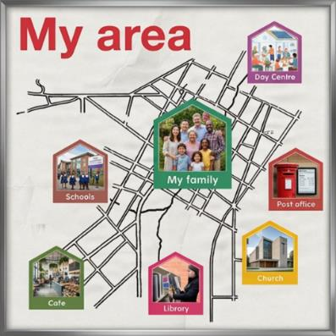 | (please tell us here)


How do you think this option would affect families who want a Catholic school place?
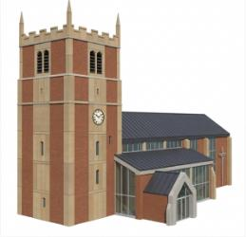 | (please tell us here)


How do you think this option would affect children and young people with SEND (Special Educational Needs and Disabilities)?
 | (please tell us here)

 How would getting to school change for you?
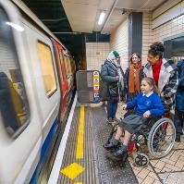 | (please tell us here)

 Do you have any other comments about option 3?
 | (please tell us here)

Other ideas
Do you have any other ideas for the future of St Patrick’s Catholic School?
 | (please tell us here)

Remember to return this completed questionnaire by 9am on Monday 14 December by:

- returning this questionnaire to St Patrick’s Catholic Primary School

- emailing your completed questionnaire to stpatricksconsultation@camden.gov.uk

posting your completed questionnaire to
SSP Consultation
Participation and Partnerships
Floor 5 at 5PS
FREEPOST RUCA–AXAS–ZEUS
London Borough of Camden
Town Hall
London
WC1H 9JE

