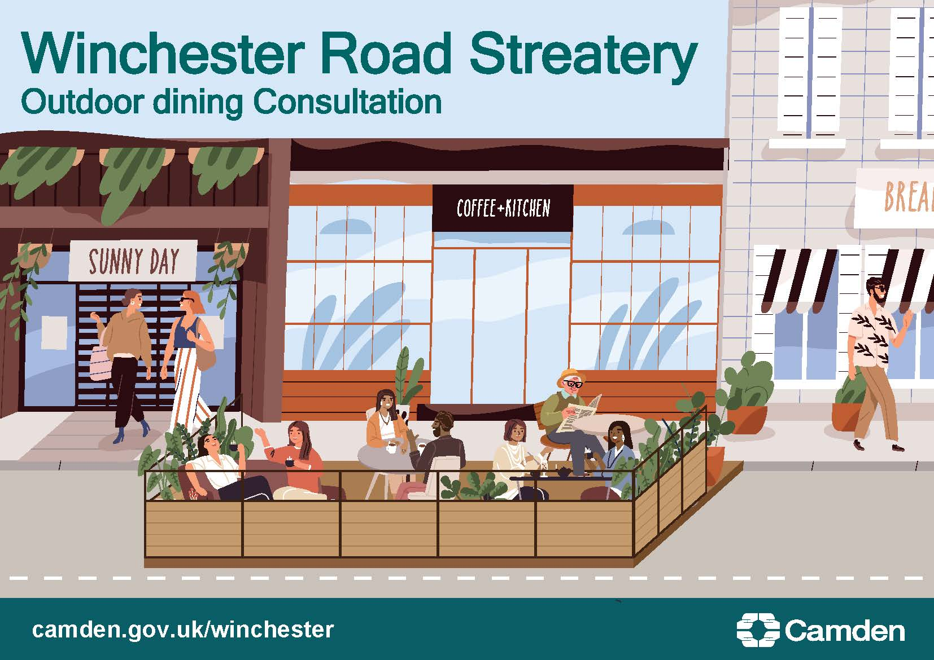
Streateries consultation - Conway Street
Our proposal to make the Streatery permanent

What’s the challenge on Conway Street?

The COVID-19 pandemic has changed how people in Camden live, travel and work. We want our streets to be safe spaces for you to walk and cycle, for children to get to and from school safely and healthily, for businesses to be able to flourish and for you to be breathing cleaner air. We want to ensure that our streets support a strong recovery from the pandemic so we can provide a lasting legacy of greener, safer, healthier travel with places for people to spend time in and enjoy, regenerating our local town centres.

To help, we have been making temporary changes across Camden in our Streateries Programme: Streateries changed parking bays to spaces in the road for businesses to place tables and chairs for al fresco dining, protected by barriers. This means pedestrians, wheelchair and buggy users can pass safely on the pavement.

Camden’s town centres and High Streets are at the heart of local communities and community life; they are places where residents, workers and visitors shop, work, socialise, and access culture and services. However, they have been facing a range of challenges in recent years with a shift away from traditional retail to online shopping, accelerated by the pandemic. In response Camden has developed a Future High Streets programme to support our high streets into a robust recovery and reorientate them for a new future role so that they continue to add to community life. Streateries are essential for delivering this vision: they help to revitalise streets, creating destinations for residents and visitors to meet, socialise and spend time, adding to street life and vibrancy, increasing footfall, and regenerating the wider local economy.

We are now consulting on making some Streateries permanent, to help businesses in the Borough who wish to continue using the Streatery spaces, subject to approval of licence applications. This includes the Lore of the Land pub on Conway Street.

We implemented the Streatery on Conway Street as a trial in July 2021, under an Experimental Traffic Order as part of Phase 3 of our Streatery programme. The decision report related to this Experimental Traffic Order was approved on 29 June 2021 and can be found here. This decision report noted that a further consultation, after approximately 12 months of the trial scheme being implemented, would take place relating to any proposed permanent changes.

This consultation now asks local residents and stakeholders to give their views on whether or not this Streatery should be made permanent after the end of the 18-month Experimental Traffic Order trial period.

What is being proposed?

It is proposed to retain the Streatery permanently outside the Lore of the Land pub, No 4, Conway Street with the following measures:

- Permanently retain the space created from the removal of 11 metres of double yellow lines outside the pub, to provide 11 metres of Streatery space, protected by barriers for tables and chairs.
- Permanently retain the relocated dockless bike hire/e-scooter parking bay that was created from converting 5.5 metres of double yellow lines outside No 8 Conway Street, and permanantly reinstate the double yellow lines outside No.3 Conway Street (opposite the pub).
- Permanently retain the relocated green badge disabled parking bay that was created from converting 5.5 metres of single yellow outside No.10 Conway Street and retain the single yellow lines outside No 9 Conway Street.
- Permanently retain one-way southbound for motor traffic on Conway Street from the junction with Grafton Way to the junction with Maple Street, with two-way cycling allowed.
- Permanently retain one-way for motor traffic eastbound on Grafton Way, from the junction with Cleveland Street to the junction with Conway Street, with two way cycling allowed.
After the consultation, we will carefully consider all the responses alongside other information, to help us decide whether or not to retain the Streatery on Conway Street permanently. Should a decision be made to retain the Streatery, we would implement a permanent Traffic Management Order.

