Safe and Healthy Street schemes
Example changes

See below for examples of some different features being added to Safe and Healthy Street schemes across Camden which relate to the Fitzrovia Area Phase 1 Safe and Healthy Streets scheme. If you have any questions you can email at safetravel@camden.gov.uk .
A rain garden on a pavement buildout | Continuous Footway / Pavement
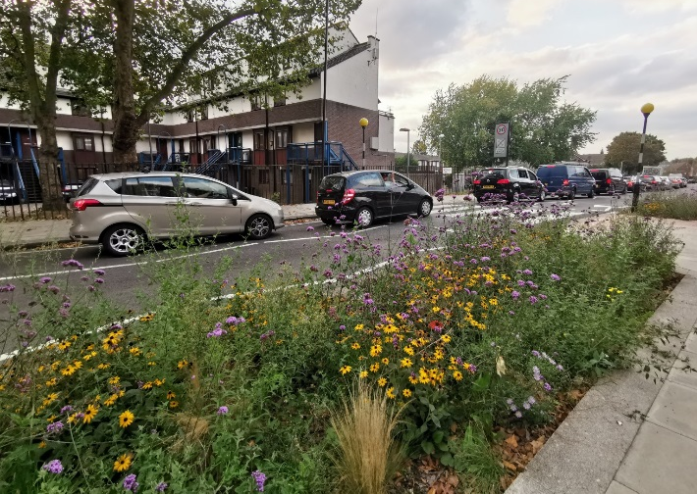 | 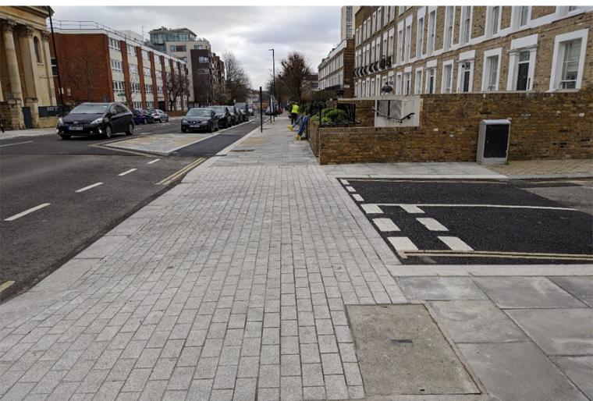
Cycle parking stands | A dockless e-scooter & cycle hire parking bay
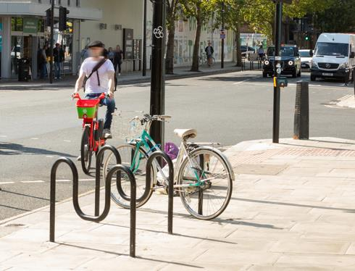 | 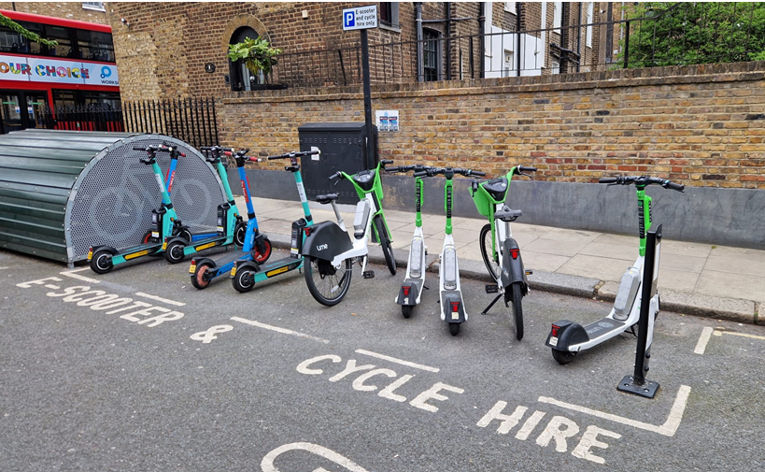
A bike hangar | A tree in a pavement build-out/extension
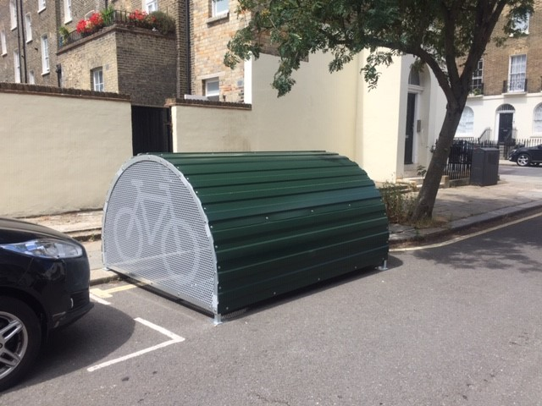 | 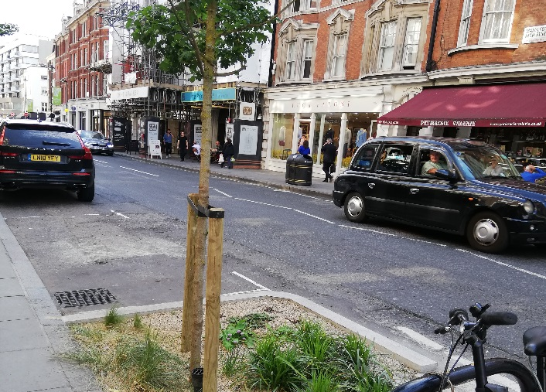
A traffic filter / traffic restriction with droppable bollard and planters | No entry area except for cyclists
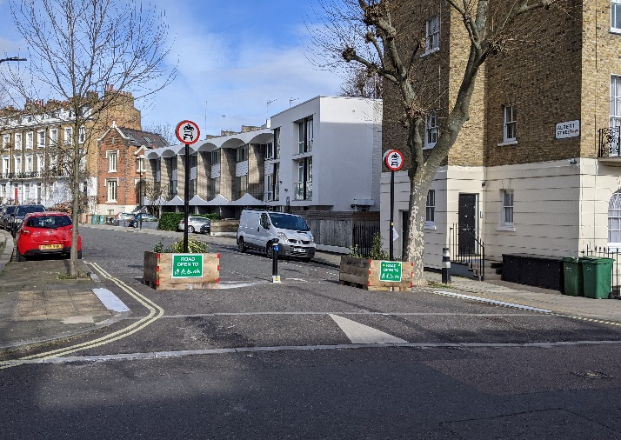 | 