Frequently asked questions
How does the rental of a space in a bike hangar work?
Each bike hangar has space for either 3 bikes or 6 bikes and they are installed on your street. Users can rent a space and have a key to access the unit and users will be sharing the bike hangar with up to 2 or 5 other neighbours.
How much does it cost to rent a space?
A rental space is charged annually and collected online by debit or credit card and the annual costs depends on the borough in which the bike hangar is installed but users typically pay between £40 a year. There is also a one off refundable key deposit priced at £20. This is to cover the cost of replacing a lost key and the administration of issuing new keys to all users of the bike hangar.
How many spaces can I rent?
Usually a bike space is allocated one space per household.
Which space should I use inside the bike hangar?
Each bike hangar has an allocated space e.g. A, B, C, D, E or F and these letters are visible above each space when you open the bike hangar. Each user is allocated with a specific space (letter) to use within the bike hangar. All users need to stick to their allocated space as using a different space causes disruption for the other users in the bike hangar.
How are spaces managed and allocated?
Unless a borough asks us to allocate spaces based on pre-set criteria (with specific questions asked on sign up e.g. does applicant have access to a secure internal space or back garden to park their bike) then spaces are allocated on a first come first served basis with particular preference for those users who live nearest the bike hangar.
What happens if I lose my key or card?
A replacement key is available for £20. All replacement keys must be paid for in advance.
How do I open and close the bike hangar?
You need to use the key to unlock the bike hangar and then turn the handle to open and similarly you need to turn the handle back and turn the key in the lock to close the bike hangar. Really important for all users that you remember that you need to use your key to lock the bike hangar after closing the bike hangar to ensure it is properly locked and secure. Please see the opening and closing instructions on the drawing below as well.
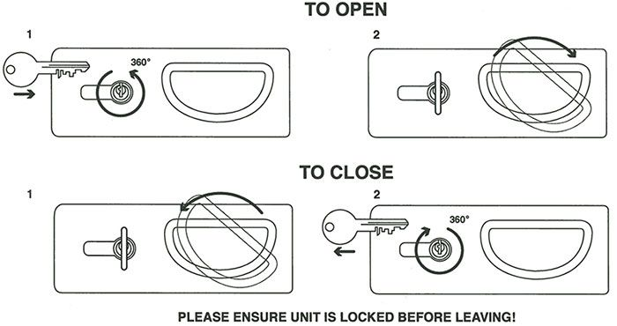
Can I cancel my membership?
We offer a 14 day cooling off period during which you can cancel your membership for any reason and get your money back.
How do I cancel my membership?
All cancellations must be made in writing to accounts@h2clubs.co.uk and we will confirm acceptance of any cancellations by email.
Will my bike be safe in the hangar?
We have done our best to make the bike hangar as secure as possible however we advise all members to lock their bikes in the bike hangar with a D-lock for added security.
Reporting problems with the bike hangar?
Members are requested to report problems with the bike hangar via our website using the form at https://www.h2bikerun.co.uk/h2asgard/report-a-problem/ and if possible attach a photo of the issue as this will help us identify and solve the issue reported with the bike hangar.
Who is responsible for any damage to my bike? Will my contents insurance cover theft?
Each user uses the bike hangar at their own risk. As operator, H2 Asgard, nor the Council, are responsible for the loss, damage or theft of bicycles, locks or any other items stored in the bike hangar. However, please note that most insurance companies class bike hangars as a secure building relating to the household and therefore you should be able to obtain insurance cover to cover you in the unlikely event of a theft from a bike hangar.

