Holmes Road Area Safe and Healthy Streets Scheme

Monitoring Factsheet
This document sets out the monitoring data gathered during the trial period of the Holmes Road Area Safe and Healthy Streets Scheme. It has been gathered and analysed to help assess the impact of the scheme during the trial period of operation. The data and feedback are summarised below.
Traffic Count Data
Traffic data before and after the implementation of the trial scheme was collected through Automatic Traffic Counts (ATCs) on streets within and outside the scheme area. ‘Before trial scheme’ data was collected in January 2022 and ‘During trial scheme’ data was collected in December 2022 (after 6 months) and May 2023 (after 12 months) when the trial scheme was live.
Traffic counts (including car, van, lorry, bus, cycle, and motorcycle) were untaken over the following periods:
- The week commencing 24th January 2022 (before trial scheme)
- The week commencing 10th December 2022 (during scheme trial)
- The week commencing 15th May 2023 (during scheme trial after 12 months)
Traffic was counted during school term time when all pupils were attending St. Patrick's Catholic Primary School.
Data was also collected using a Vivacity sensor located on Holmes Road directly outside St Patrick’s Catholic Primary School. The Vivacity sensor covers the pavements in addition to the road and counts pedestrian, car, van, lorry, bus, cycle, and motorcycle data. The Vivacity senor was installed on 22 March 2022.
Figure 1 below presents the traffic count locations.

Figure 1: Location of Traffic Counts
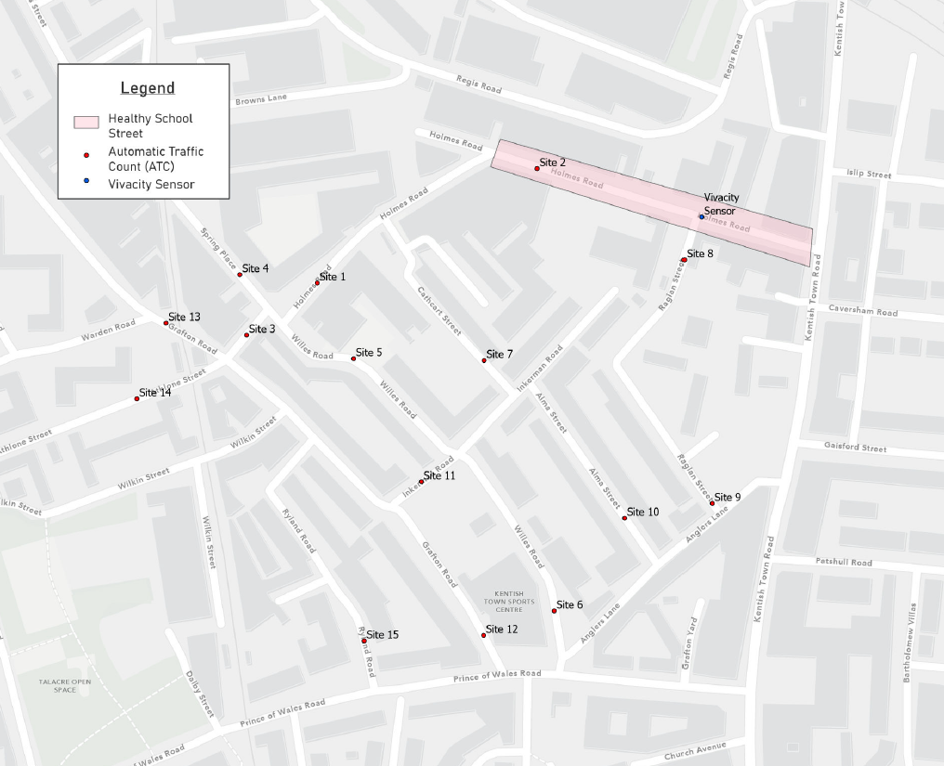
Average Motor Vehicle Traffic Counts During Healthy School Street Restriction Times
The results presented in Table 1 below show the 5-day average daily traffic flows during the morning peak (8am – 10am) and afternoon peak (2pm – 4pm) Healthy School Street restriction times (excluding cycles).
Table 1: Motor Traffic Count Data: Average Vehicle Counts (Monday to Friday, AM and PM during Healthy School Street restriction times)
Site | AM Peak (8-10am) |  |  |  |  | PM Peak (2-4pm)
 | Jan-22 | Dec-22 | May-23 | Change (Jan-22 to Dec-22) | Change (Jan-22 to May-23) | Jan-22 | Dec-22 | May-23 | Change (Jan-22 to Dec-22) | Change (Jan-22 to May-23)
Site 1 - Holmes Rd | 672 | 171 | 292 | -501 (-75%) | -379 (-56%) | 520 | 186 | 307 | -333 (-64%) | -212 (-41%)
Site 2 - Holmes Rd | 533 | 62 | 125 | -470 (-88%) | -408 (-77%) | 465 | 93 | 162 | -372 (-80%) | -303 (-65%)
Site 3 - Holmes Rd | 455 | 353 | 320 | -102 (-22%) | -135 (-30%) | 390 | 302 | 322 | -88 (-23%) | -69 (-18%)
Site 4 - Spring Pl | 163 | 131 | 143 | -32 (-19%) | -20 (-12%) | 165 | 140 | 137 | -25 (-15%) | -28 (-17%)
Site 5 - Willes Rd | 126 | 256 | 187 | 130 (103%) | 61 (48%) | 104 | 213 | 159 | 109 (105%) | 56 (54%)
Site 6 - Willes Rd | 129 | 242 | 218 | 112 (87%) | 89 (69%) | 139 | 234 | 217 | 94 (68%) | 77 (56%)
Site 7 - Cathcart St | 58 | 43 | 60 | -15 (-26%) | 2 (3%) | 49 | 25 | 51 | -24 (-49%) | 2 (4%)
Site 8 - Raglan St | 62 | 4 | 11 | -59 (-94%) | -51 (-83%) | 57 | 7 | 16 | -49 (-87%) | -41 (-72%)
Site 9 - Raglan St | 54 | 52 | 50 | -3 (-5%) | -4 (-7%) | 51 | 51 | 59 | 0 (0%) | 9 (17%)
Site 10 - Alma St | 49 | 30 | 41 | -19 (-39%) | -8 (-16%) | 41 | 38 | 45 | -3 (-6%) | 4 (9%)
Site 11 - Inkerman Rd | 62 | 55 | 52 | -7 (-12%) | -10 (-17%) | 42 | 42 | 48 | 0 (0%) | 6 (15%)
Site 12 - Grafton Rd | 268 | 297 | 296 | 29 (11%) | 28 (11%) | 274 | 319 | 324 | 45 (16%) | 50 (18%)
Site 13 - Grafton Rd | 259 | 224 | 230 | -34 (-13%) | -29 (-11%) | 315 | 326 | 279 | 11 (3%) | -36 (-12%)
Site 14 - Athlone St | 361 | 252 | 319 | -109 (-30%) | -42 (-12%) | 285 | 244 | 302 | -41 (-14%) | 17 (6%)
Site 15 - Ryland Rd | 95 | 86 | 41 | -9 (-9%) | -54 (-57%) | 86 | 88 | 55 | 2 (2%) | -32 (-37%)
Total | 3346 | 2257 | 2385 | -1089 (-33%) | -960 (-29%) | 2983 | 2308 | 2483 | -675 (-23%) | -500 (-17%)
When comparing the traffic count data collected on Holmes Road within the Healthy School Street restriction area (Site 2), between January 2022 (before trial scheme) and May 2023 (during trial scheme after 12 months), a 77% reduction in motor vehicle traffic was observed during the morning restriction period and a 65% reduction during the afternoon restriction. This equates to averages of 408 fewer vehicles in the morning and 303 fewer vehicles in the afternoon.
Several other streets also recorded a reduction in motor vehicle traffic volumes during the morning and afternoon restrictions. The most significant percentage reductions were recorded at Site 8 - Raglan St (where an at all times motor vehicle restriction was installed) where traffic volumes reduced by -83% (-51 vehicles) during the AM Peak and -72% (-41 vehicles) during the PM Peak, Site 15 - Ryland Rd where traffic volumes reduced by -57% (-54 vehicles) during the AM Peak and -37% (-32 vehicles) during the PM Peak, Site 1 (Holmes Road between Willes Road and Cathcart Street), where traffic volumes reduced by 56% (-379 vehicles) during the AM Peak and -41% (-212 vehicles) during the PM Peak and Site 3 - Holmes Rd (between Grafton Road and Willes Road) where traffic volumes reduced by 30% (-135 vehicles) during the AM Peak.
Some streets recorded an increase in average daily motor vehicle traffic during the morning and afternoon restrictions. The most significant percentage increases were recorded at Site 6 - Willes Rd (between Anglers Lane and Inkerman Road) where traffic volumes increased by 69% (89 vehicles) during the AM Peak and 56% (77 vehicles) during the PM Peak and Site 5 - Willes Rd (between Inkerman Road and Holmes Road) where traffic volumes increased by 48% (61 vehicles) during the AM Peak and 54% (56 vehicles) during the PM Peak.
When comparing the traffic count data collected across all sites surveyed between January 2022 (before trial scheme) and May 2023 (during trial scheme after 12 months), there was an overall reduction in average traffic levels of 29% during the morning restrictions and 17% during the afternoon restrictions. This equates to averages of 960 fewer vehicles in the morning and 500 fewer vehicles in the afternoon.

Average Daily Motor Vehicle Traffic Counts
The results presented in 2 below show the 5-day average daily traffic flows (excluding cycles).
Table 2: Motor Traffic Count Data: Average Daily Vehicle Counts (Monday to Friday)
Site | Jan-22 | Dec-22 | May-23 | Change (Jan-22 to Dec-22) | Change (Jan-22 to May-23)
Site 1 - Holmes Rd | 3969 | 2477 | 3675 | -1492 (-38%) | -294 (-7%)
Site 2 - Holmes Rd | 3667 | 2495 | 3316 | -1173 (-32%) | -351 (-10%)
Site 3 - Holmes Rd | 3060 | 3057 | 3404 | -2 (0%) | 344 (11%)
Site 4 - Spring Pl | 1216 | 1214 | 1249 | -2 (0%) | 33 (3%)
Site 5 - Willes Rd | 764 | 1134 | 930 | 370 (48%) | 166 (22%)
Site 6 - Willes Rd | 960 | 1178 | 1138 | 218 (23%) | 178 (18%)
Site 7 - Cathcart St | 346 | 204 | 332 | -142 (-41%) | -14 (-4%)
Site 8 - Raglan St | 380 | 63 | 102 | -317 (-84%) | -277 (-73%)
Site 9 - Raglan St | 324 | 315 | 354 | -9 (-3%) | 30 (9%)
Site 10 - Alma St | 269 | 211 | 260 | -58 (-22%) | -9 (-3%)
Site 11 - Inkerman Rd | 288 | 265 | 302 | -23 (-8%) | 14 (5%)
Site 12 - Grafton Rd | 1956 | 2031 | 2259 | 75 (4%) | 303 (15%)
Site 13 - Grafton Rd | 2202 | 2239 | 2103 | 37 (2%) | -99 (-5%)
Site 14 - Athlone St | 2208 | 1927 | 2706 | -281 (-13%) | 498 (23%)
Site 15 - Ryland Rd | 646 | 592 | 394 | -54 (-8%) | -252 (-39%)
Total | 22253 | 19401 | 22521 | -2852 (-13%) | 267 (1%)
When comparing the traffic count data collected on Holmes Road within the Healthy School Street restriction area (Site 2), between January 2022 (before trial scheme) and May 2023 (during trial scheme after 12 months), there was a 10% reduction observed in average daily motor vehicle traffic equating to 351 fewer vehicles per day. Several other streets also recorded a reduction in average daily motor vehicle traffic. The most significant percentage reductions were recorded at Site 8 - Raglan St, where traffic volumes reduced by -73% (-277 vehicles) and Site 15 - Ryland Rd, where traffic volumes reduced by -39% (252 vehicles).
Some streets recorded an increase in average daily motor vehicle traffic. The most significant percentage increases were recorded at Site 14 - Athlone St, where traffic volumes increased by 23% (498 vehicles), Site 5 – Willes Rd (between Inkerman Road and Holmes Road), where traffic volumes increased by 22% (166 vehicles) and Site 6 - Willes Rd (between Anglers Lane and Inkerman Road) where traffic volumes increased by 18% (178 vehicles).
When comparing the traffic count data collected across all sites surveyed between January 2022 (before trial scheme) and May 2023 (during trial scheme after 12 months), there was an overall 1% increase in average daily motor vehicle traffic, equating to 267 vehicles.
Table 2 below shows the 5-day average daily traffic flows (excluding cycles) by direction on Holmes Road within the Healthy School Street restriction area (Site 2).
Table 2: Motor Traffic Count Data: Average Daily Vehicle Counts by Direction (Monday to Friday)
Site | Eastbound |  |  |  |  | Westbound
 | Jan-22 | Dec-22 | May-23 | Change (Jan-22 to Dec-22) | Change (Jan-22 to May-23) | Jan-22 | Dec-22 | May-23 | Change (Jan-22 to Dec-22) | Change (Jan-22 to May-23)
Site 2 - Holmes Rd | 1786.1 | 1305.8 | 1574.2 | -480 (-27%) | -212 (-12%) | 1881.05 | 1188.8 | 1741.6 | -692 (-37%) | -139 (-7%)
When comparing the traffic count data collected on Holmes Road within the Healthy School Street restriction area (Site 2) by direction, between January 2022 (before trial scheme) and May 2023 (during trial scheme after 12 months), there was a 12% reduction in eastbound average daily motor vehicle traffic equating to 212 fewer vehicles and a 7% reduction in westbound average daily motor vehicle traffic equating to 139 fewer vehicles.
Motor Vehicle Flows (Vivacity sensor)
Traffic data was also collected by a ‘Vivacity’ sensor, which was installed on Holmes Road within the Healthy School Street, near the junction with Raglan Street (see Figure 1). The sensor was fully operational from the 22nd March 2022 and captures 24-hour road and pavement numbers and categorises them. To understand the impact of the scheme on traffic flows, a 12-month period beginning on the 22nd March 2022 has been analysed. The traffic volumes (motor vehicles only) on weekdays during the hours of the Healthy School Street operation are shown in Figure 2.
Figure 2: Vivacity Sensor Motor Traffic Count Data: Average Vehicle Counts (Monday to Friday, during AM/PM restriction times)
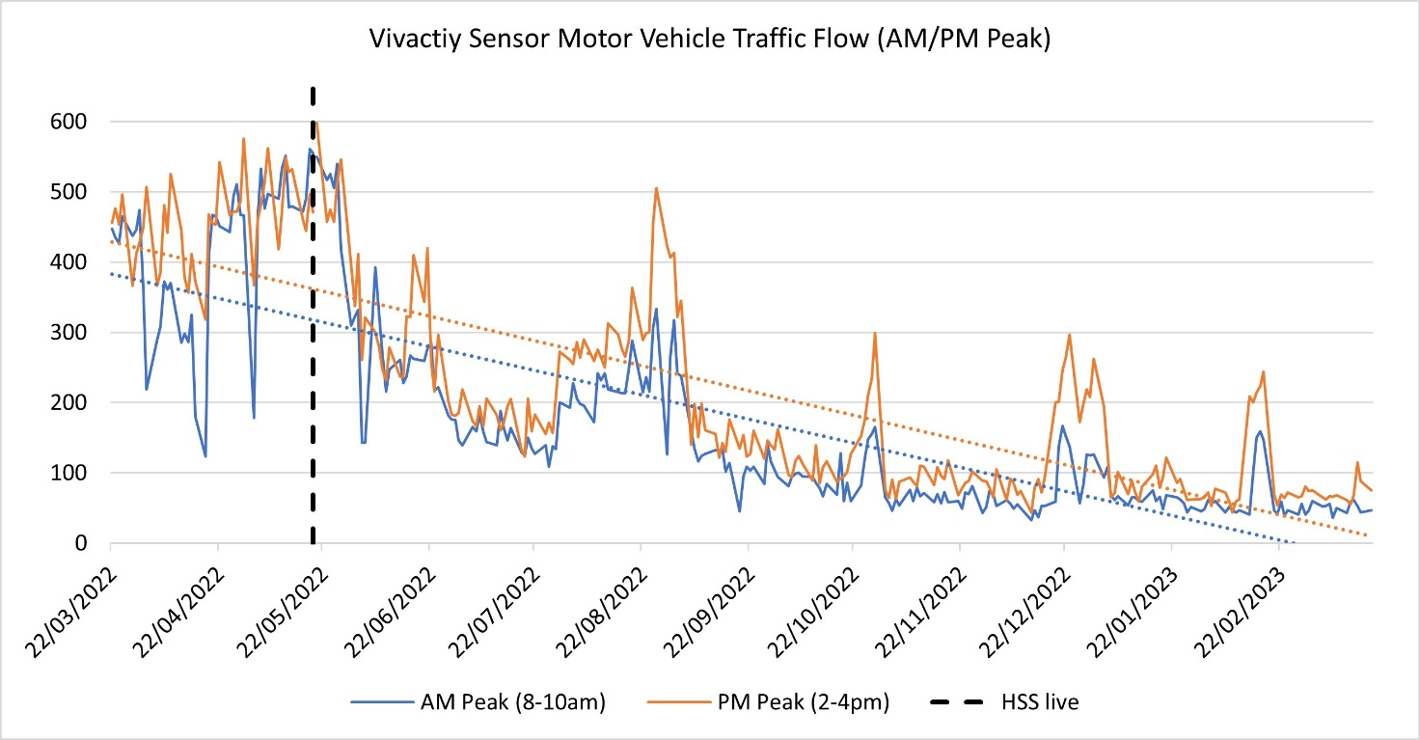
The data in Figure 2 shows that motor traffic during the AM and PM restriction times has decreased significantly following the introduction of the Healthy School Street on the 19th May 2022. The data also highlights traffic increases outside of school term times when the Healthy School Street restrictions are deactivated.
Traffic Speed Data
The Automatic Traffic Count data collected was used to analyse vehicle speeds. A comparison of speeds before and after the trial scheme was implemented is shown in Table 3 below. The data includes the average speed of all vehicle classes (including cycles).
Table 3: Traffic Speed Data (mph): Daily Average (Monday-Friday, AM and PM restriction times)
Site | AM Peak (8-10am) |  |  |  |  | PM Peak (2-4pm)
 | Jan-22 | Dec-22 | May-23 | Change (Jan-22 to Dec-22) | Change (Jan-22 to May-23) | Jan-22 | Dec-22 | May-23 | Change (Jan-22 to Dec-22) | Change (Jan-22 to May-23)
Site 1 - Holmes Rd | 15 | 13 | 14 | -2 | -1 | 16 | 15 | 17 | -1 | +1
Site 2 - Holmes Rd | 15 | 14 | 14 | -1 | -1 | 15 | 15 | 15 | No Change | No Change
Site 3 - Holmes Rd | 12 | 11 | 12 | -1 | No Change | 12 | 12 | 12 | No Change | No Change
Site 4 - Spring Pl | 15 | 13 | 15 | -2 | No Change | 15 | 14 | 15 | -1 | No Change
Site 5 - Willes Rd | 15 | 16 | 17 | +1 | +2 | 15 | 17 | 17 | +2 | +2
Site 6 - Willes Rd | 16 | 15 | 18 | -1 | +2 | 16 | 17 | 20 | +1 | +4
Site 7 - Cathcart St | 10 | 8 | 13 | -2 | +3 | 10 | 9 | 14 | -1 | +4
Site 8 - Raglan St | 11 | 8 | 11 | -3 | No Change | 12 | 9 | 12 | -3 | No Change
Site 9 - Raglan St | 14 | 10 | 13 | -4 | -1 | 14 | 12 | 14 | -2 | No Change
Site 10 - Alma St | 15 | 12 | 15 | -3 | No Change | 14 | 14 | 16 | No Change | +2
Site 11 - Inkerman Rd | 12 | 11 | 13 | -1 | +1 | 12 | 12 | 13 | No Change | +1
Site 12 - Grafton Rd | 15 | 14 | 15 | -1 | No Change | 16 | 15 | 16 | -1 | No Change
Site 13 - Grafton Rd | 15 | 16 | 14 | +1 | -1 | 16 | 15 | 14 | -1 | -2
Site 14 - Athlone St | 16 | 14 | 15 | -2 | -1 | 16 | 15 | 16 | -1 | No Change
Site 15 - Ryland Rd | 11 | 9 | 11 | -2 | No Change | 12 | 10 | 11 | -2 | -1
When comparing the speed data collected in January 2022 (before trial scheme) with the data collected in May 2023 (during trial scheme after 12 months), average speeds recorded on Holmes Road within the Healthy School Street restriction area (Site 2) reduced by 1 mph during the AM Peak and stayed the same (no change) during the PM Peak. Average traffic speeds on some of the remaining streets increased, with the most notable increase being on Cathcart Street during the AM peak (+3mph) and Willes Road/Cathcart Street during the PM peak (+4mph). Average speeds recorded at all sites were below the 20mph speed limit in the during trial scheme scenario.
Cycle Flows (ATC)
A comparison of cycle flows for the roads surveyed using Automatic Traffic Counts is shown in Table 4.
Table 4: Cycle Count Data: Daily Average Counts (Monday to Friday, AM and PM restriction times)
Site | AM Peak (8-10am) |  |  |  |  | PM Peak (2-4pm)
 | Jan-22 | Dec-22 | May-23 | Change (Jan-22 to Dec-22) | Change (Jan-22 to May-23) | Jan-22 | Dec-22 | May-23 | Change (Jan-22 to Dec-22) | Change (Jan-22 to May-23)
Site 1 - Holmes Rd | 66 | 38 | 48 | -28 (-42%) | -18 (-27%) | 40 | 34 | 26 | -6 (-15%) | -14 (-35%)
Site 2 - Holmes Rd | 69 | 19 | 68 | -50 (-72%) | -1 (-1%) | 41 | 20 | 52 | -21 (-51%) | 11 (27%)
Site 3 - Holmes Rd | 50 | 13 | 39 | -37 (-74%) | -11 (-22%) | 31 | 20 | 30 | -11 (-35%) | -1 (-3%)
Site 4 - Spring Pl | 32 | 8 | 39 | -24 (-75%) | 7 (22%) | 19 | 9 | 31 | -10 (-53%) | 12 (63%)
Site 5 - Willes Rd | 23 | 9 | 31 | -14 (-61%) | 8 (35%) | 16 | 10 | 21 | -6 (-38%) | 5 (31%)
Site 6 - Willes Rd | 32 | 15 | 44 | -17 (-53%) | 12 (38%) | 14 | 11 | 16 | -3 (-21%) | 2 (14%)
Site 7 - Cathcart St | 9 | 1 | 14 | -8 (-89%) | 5 (56%) | 5 | 0 | 4 | -5 (-100%) | -1 (-20%)
Site 8 - Raglan St | 8 | 1 | 4 | -7 (-88%) | -4 (-50%) | 5 | 1 | 7 | -4 (-80%) | 2 (40%)
Site 9 - Raglan St | 4 | 1 | 6 | -3 (-75%) | 2 (50%) | 5 | 4 | 6 | -1 (-20%) | 1 (20%)
Site 10 - Alma St | 7 | 3 | 12 | -4 (-57%) | 5 (71%) | 6 | 5 | 10 | -1 (-17%) | 4 (67%)
Site 11 - Inkerman Rd | 5 | 2 | 8 | -3 (-60%) | 3 (60%) | 5 | 3 | 6 | -2 (-40%) | 1 (20%)
Site 12 - Grafton Rd | 77 | 22 | 127 | -55 (-71%) | 50 (65%) | 38 | 16 | 66 | -22 (-58%) | 28 (74%)
Site 13 - Grafton Rd | 89 | 16 | 147 | -73 (-82%) | 58 (65%) | 47 | 22 | 84 | -25 (-53%) | 37 (79%)
Site 14 - Athlone St | 21 | 7 | 27 | -14 (-67%) | 6 (29%) | 14 | 11 | 21 | -3 (-21%) | 7 (50%)
Site 15 - Ryland Rd | 11 | 1 | 14 | -10 (-91%) | 3 (27%) | 4 | 1 | 8 | -3 (-75%) | 4 (100%)
Total | 503 | 156 | 628 | -347 (-69%) | 125 (25%) | 290 | 167 | 388 | -123 (-42%) | 98 (34%)
When comparing the traffic count data collected on the section of Holmes Road within Healthy School Street restriction area (Site 2) from January 2022 (before trial scheme) to May 2023 (during trial scheme after 12 months), there was a 1% reduction during the AM peak and a 27% increase during the PM peak. This equates to a reduction of one cyclist during the morning restrictions and 11 additional cyclists during the afternoon restrictions. Cycle volumes increased on all remaining streets except for Site 1 – Holmes Road (between Willes Road and Cathcart Street), Site 3 - Holmes Rd (between Grafton Road and Willes Road) and Site 8 - Raglan St during the AM Peak and on all streets except for Site 1 – Holmes Road (between Willes Road and Cathcart Street), Site 3 - Holmes Rd (between Grafton Road and Willes Road) and Site 7 - Cathcart St during the PM peak. Across all of the sites surveyed before and after the implementation of the trial scheme, there was an overall 25% increase (125 cycles) during the morning restrictions and a 34% increase (98 cycles) during the afternoon restrictions.
Cycle/Pedestrian Flows (Vivacity sensor)
Cycle and pedestrian count data was also collected by the ‘Vivacity’ sensor, which was installed on Holmes Road, near the junction with Raglan Street. The sensor was fully operational from the 22nd March 2022 and captures 24-hour road and pavement numbers and categorises them. To understand the impact of the scheme on cycle and pedestrian flows, a 12-month period beginning on the 22nd March 2022 has been analysed. The total pedestrian and cycle volumes on weekdays during the hours of the Healthy School Street operation are shown in Figure 3 and Figure 4 below.
Figure 3: Vivacity Sensor Pedestrian Count Data: Average Pedestrian Flows (Monday to Friday, during AM/PM restriction times)
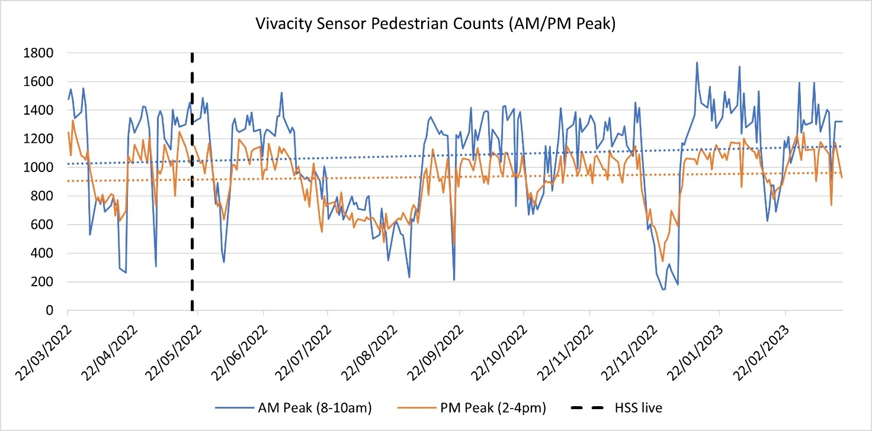
The data in Figure 3 shows that pedestrian volumes on Holmes Road during the AM and PM restriction times have increased gradually following the introduction of the Healthy School Street on the 19th May 2022.

Figure 4: Vivacity Sensor Cycle Count Data: Average Cycle Flows (Monday to Friday, during AM/PM restriction times)
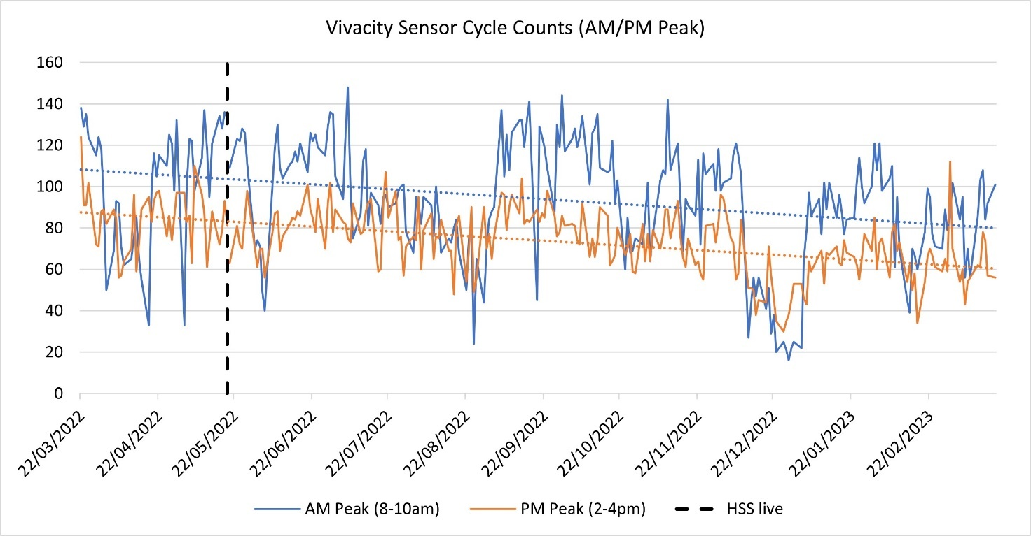
The data in Figure 4 shows that cycle volumes on Holmes Road during the AM and PM restriction times have decreased gradually following the introduction of the Healthy School Street on the 19 May 2022. It should be noted that whilst the trend shows a slight reduction in cycling across the year, this could be due to several factors, including changes in weather patterns and traffic management in the area.
Air Quality Monitoring
Air quality monitoring diffusion tubes are in place on Holmes Road, Raglan Street and Inkerman Road, all of which are in close proximity to St. Patrick’s School. Air quality data was monitored between Jun-Dec 2021 (before trial scheme) and Jun-Dec 2022 (during trial scheme). Diffusion tubes were installed to monitor the impacts of the Healthy School Street trial and the results are shown in Table 5.
Table 5: Raw diffusion tube NO2 Data 2021-2022
Site | Raw NO₂ concentration, µg/m³ |  |  | Change in NO₂ concentration
 | 2021 (Jun-Dec) | 2022 (Jun-Dec) | Months included | Change in µg/m³ | % change
Holmes Road outside St. Patrick’s School | 24.31 | 23.56 | Jun/Jul/Aug/Sep/Nov/Dec | -0.75 | -3.1%
Raglan Street outside St. Patrick’s School | 22.92 | 21.57 | Jun/Jul/Aug/Sep/Oct/Nov/Dec | -1.35 | -5.9%
Inkerman Road outside St. Patrick’s School | 22.15 | 22.33 | Jun/Jul/Aug/Oct/Nov/Dec | 0.18 | 0.8%
Average over all sites |  |  |  | -0.64 | -2.7%
The data presented in the table above is raw and unratified without applying the national bias adjustment factors. This is because the analysis has only used a selection of months rather than the full calendar annual mean NO2 concentrations which is not available. However, it shows us that harmful NO2 concentrations reduced on both Holmes Road (-3.1%) and Raglan Street (-5.9%), when comparing data collected before and after the Healthy School Street was implemented. NO2 concentrations increased by 0.8% on Inkerman Road.
The summary statistics show that the average change in NO2 from 2021 to 2022 across all three sites was a reduction both in absolute terms (-0.64µg/m3 of NO2) and as a percentage (-2.7%). The data shows that for the months surveyed, all sites were below the current legal limit of 40ug/m3, and the sites will continue to be monitored if the scheme is made permanent.
It is important to note that transport contributes around 31% of total NO2 emissions in Camden over the course of a year. The majority of the remainder comes from gas use in building heating systems. This means that there is significant seasonal variation in outdoor NO2 concentrations when heating demand is higher during cold weather. The change in NO2 concentration at a particular location will not entirely be the result of changes in traffic volumes and there are other local factors affecting air quality. The Council has committed to achieving the updated World Health Organisation’s standards of 10ug/m3 by 2034.
Feedback During the Experimental Traffic Order Period
Throughout the trial, an online Commonplace survey was open for people to provide feedback on the scheme. The survey link was shared on all written (letters/posters) communications about the scheme and a survey reminder was sent out to residents and businesses 6 months into the trial. If a respondent did not have internet access a phone number was available on all communication materials to request a paper copy. 90 comments on the scheme were received during the trial. Within this total, 55 of the respondents were positive/mostly positive towards the changes, with 27 being negative/mostly negative (see Figure 5).
Figure 5: Type of comments received during the trial
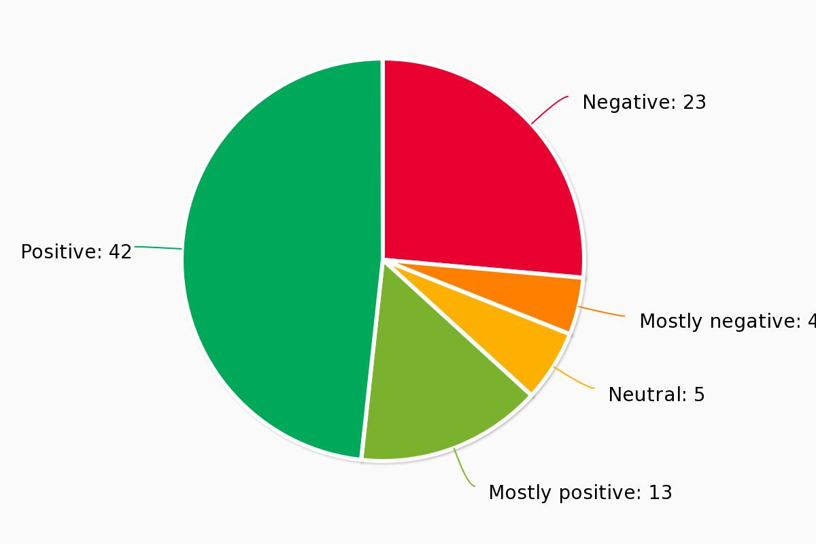

The key comments received that were positive towards the trial changes include:

- The restriction has made Holmes Road and other nearby streets quieter and made it easier to walk/cycle in the area.
- The restriction has improved air quality.
- Has improved safety conditions for children who live/attend schools in the area.

The key comments received that were negative towards the trial changes include:

- People now have to make longer car journeys to avoid the restrictions.
- Some people should be exempt from the restrictions including disabled people and residents who live in the area.
- The restrictions make it harder for people to access their homes.
- Traffic has increased on nearby streets in the area.
- Traffic levels on Holmes Road are still bad outside the restriction times.
- Some drivers ignore the restrictions making it more dangerous for children.

The key suggestions for improvement include:

- The scheme should be extended to include the Collège Français Bilingue de Londres as many parents still drive to this school.
- Holmes Road and other streets in the area should be permanently closed to motor vehicles or made one-way.
- The pavements in front of the school are too narrow and need to be widened.
- The permanent scheme should include more plants and trees.

