Somers Town Healthy School Streets

See below images showing the different features being proposed as part on the consultation on the Somers Town Healthy School Streets. If you have any questions, please contact safetravel@camden.gov.uk.

Cycle Parking Stands
Bike Hangar for Residents
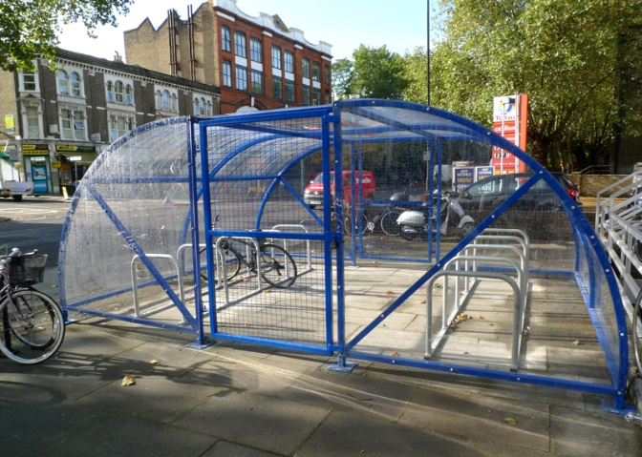

Example from Cyclehoop

E-Scooter and Dockless Bike Bay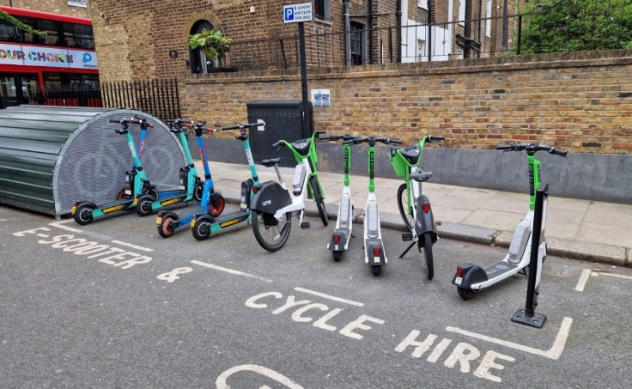
Rain Gardens
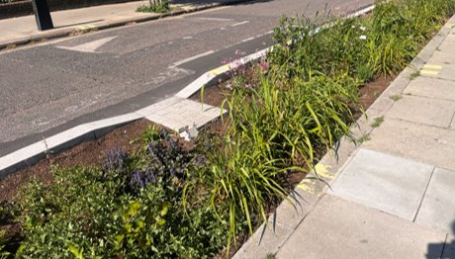

Continuous Crossing

Bike Hangar
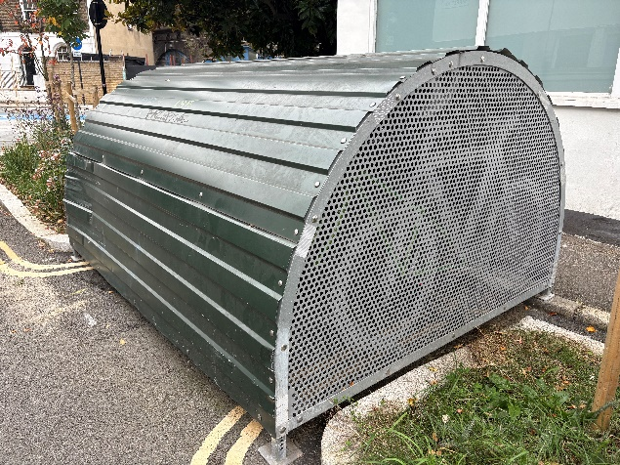
Uncontrolled Crossing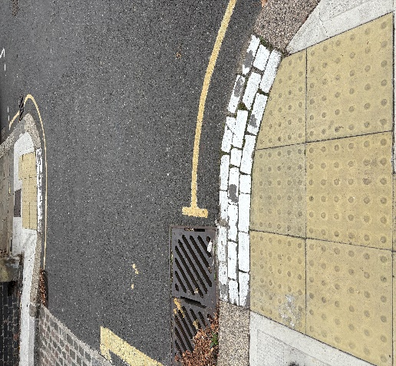
Raised Zebra Crossing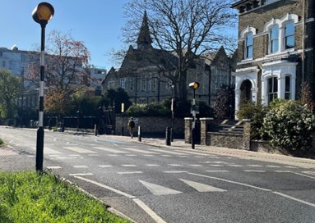
Tactile Paving


