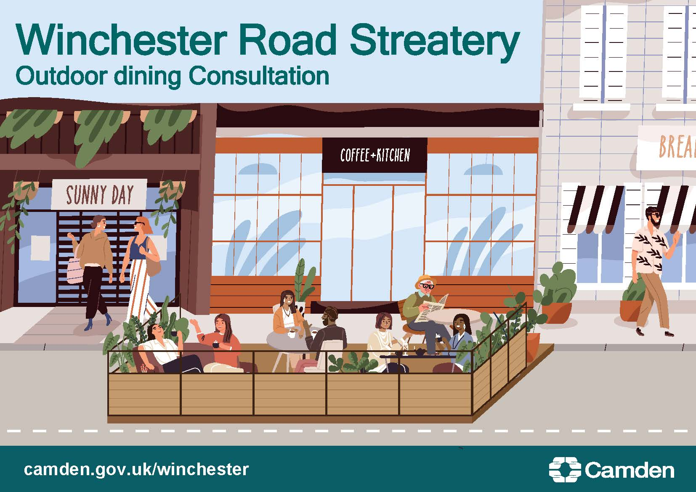
Streateries consultation – Whitfield Street
Our proposal to make the Streatery permanent

What’s the challenge on Whitfield Street?

The COVID-19 pandemic has changed how people in Camden live, travel and work. We want our streets to be safe spaces for you to walk and cycle, for children to get to and from school safely and healthily, for businesses to be able to flourish and for you to be breathing cleaner air. We want to ensure that our streets support a strong recovery from the pandemic so we can provide a lasting legacy of greener, safer, healthier travel with places for people to spend time in and enjoy, regenerating our local town centres.

To help, we have been making temporary changes across Camden in our Streateries Programme: Streateries changed parking bays to spaces in the road for businesses to place tables and chairs for al fresco dining, protected by barriers. This means pedestrians, wheelchair and buggy users can pass safely on the pavement.

Camden’s town centres and High Streets are at the heart of local communities and community life; they are places where residents, workers and visitors shop, work, socialise, and access culture and services. However, they have been facing a range of challenges in recent years with a shift away from traditional retail to online shopping, accelerated by the pandemic. In response Camden has developed a Future High Streets programme to support our high streets into a robust recovery and reorientate them for a new future role so that they continue to add to community life. Streateries are essential for delivering this vision: they help to revitalise streets, creating destinations for residents and visitors to meet, socialise and spend time, adding to street life and vibrancy, increasing footfall, and regenerating the wider local economy.

We are now consulting on making some Streateries permanent, to help businesses in the Borough who wish to continue using the Streatery spaces, subject to approval of licence applications. This includes Gigs on Whitfield Street.

We implemented the Streatery on Whitfield Street as a trial in July 2021, under an Experimental Traffic Order as part of Phase 3 of our Streatery programme. The decision report related to this Experimental Traffic Order was approved on 29 June 2021 and can be found here. The decision report noted that a further consultation, after approximately 12 months of the trial scheme being implemented, would take place relating to any proposed permanent changes.

This consultation now asks local residents and stakeholders to give their views on whether or not this Streatery should be made permanent after the end of the 18-month Experimental Traffic Order trial period.

What is being proposed?

It is proposed to make the Streatery on Whitfield Street permanent with the following measures:

- permanently retain the Streatery space which was created from the removal of 10 metres of paid-for-parking and 1.5 metres of double yellow lines on Whitfield Street. This provides a safe space, protected by barriers, for tables and chairs

After the consultation, we will carefully consider all the responses alongside other information, to help us decide whether or not to retain the Streatery on Whitfield Street permanently. Should a decision be made to retain the Streatery, we would implement a permanent Traffic Management Order.

