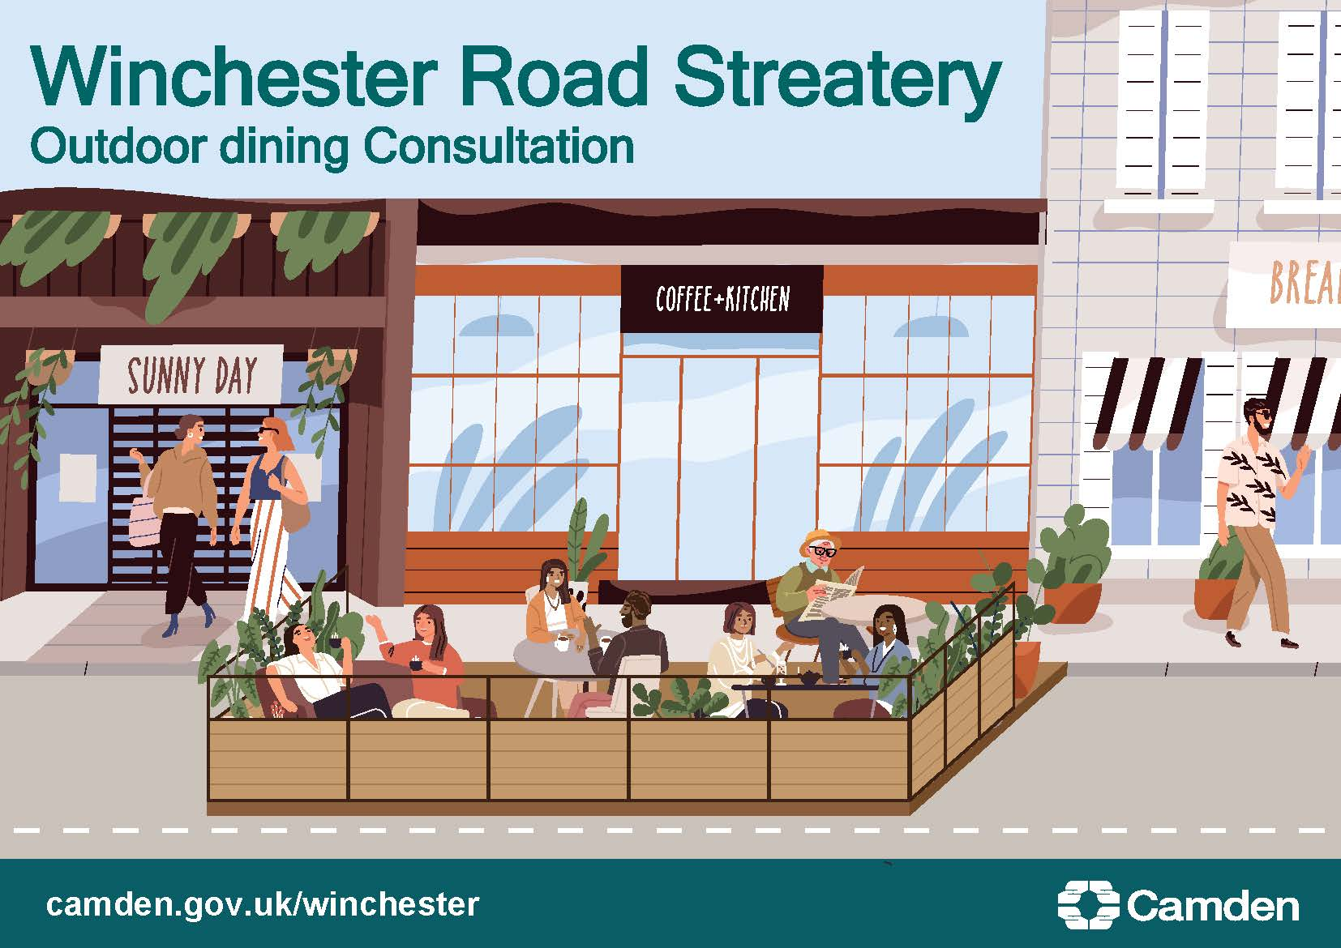.

Streateries consultation – Whitfield Street

What’s the challenge on Whitfield Street?

The COVID-19 pandemic has changed how people in Camden live, travel and work. Since the start of the pandemic many of us have been spending more time closer to home, making our neighbourhoods more important than ever. We want our streets to be safe spaces for you to walk and cycle, for children to get to and from school safely and healthily, for businesses to be able to flourish and for you to be breathing cleaner air. COVID-19 has created new challenges for our local economy and the Council is committed to supporting our local businesses to reopen safely as lock down measures ease. We are working to provide new ways to support and boost our local high streets and town centres whilst keeping them safe and secure for our communities.

In 2020 the UK Government introduced new legislation to make it easier for businesses to apply for licences to place tables and chairs on the pavement, but many pavements in the borough are too narrow to allow them. During 2020 we set up a Streateries programme to support the hospitality sector, enabling them to re-open and trade during the summer months with more outdoor space. A Streatery is a car free outdoor dining space in the road protected by barriers around the new space, where businesses can place tables and chairs for outdoor dining and so that pedestrians can pass safely on the pavement.

Camden’s local Town Centres and High Streets are at the heart of local communities and Streateries have a key role to play in their successful re-opening and recovery. They help to create destinations for residents and visitors to meet and socialise, adding to street life and vibrancy, increasing footfall and regenerating the wider local economy.

To help the hospitality sector's recovery, we are now proposing new temporary Streatery locations, based on received applications for pavement licenses. We are consulting now to help those businesses across the Borough who wish to have additional space for outdoor dining, to trade safely.

What is being proposed?

Whitfield Street in Fitzrovia has several cafes, bars and restaurants. A Streatery is proposed on Whitfield Street, outside Gigs, close to the junction with Tottenham Street, as a trial. We are now carrying out a consultation and we want you to have a say to help shape the new designs.

We propose to:

- Temporarily remove 10 metres of paid-for-parking and 1.5 metres of double yellow lines on Whitfield Street, outside Gigs (address 12 Tottenham Street), to provide 11.5 metres of temporary outdoor space, protected with barriers around the new space, for tables and chairs.

After the consultation, we will carefully consider the responses, alongside other information, to help us decide whether or not to progress the scheme. Should a decision be made to proceed, we would implement the changes on a trial basis under an Experimental Traffic Order (ETO) during which time people will be invited to provide feedback. We will undertake public consultation after 12 months of the trial the results of which, together with feedback received during the trial and monitoring data, will inform a decision as to whether or not to make the Streatery permanent.

